


S-125
Published by the
International Hydrographic Organization
4b quai Antoine 1er
Principauté de Monaco
Tel: (377) 93.10.81.00
Fax: (377) 93.10.81.40
info@iho.int
www.iho.int
MARINE AIDS TO NAVIGATION (AtoN)

Edition 0.0.4 – April 2025

© Copyright International Hydrographic Organization March 2025
This work is copyright. Apart from any use permitted in accordance with the Berne Convention for the Protection of Literary and Artistic Works (1886), and except in the circumstances described below, no part may be translated, reproduced by any process, adapted, communicated or commercially exploited without prior written permission from the International Hydrographic Organization Secretariat (IHO Secretariat). Copyright in some of the material in this publication may be owned by another party and permission for the translation and/or reproduction of that material must be obtained from the owner.
This document or partial material from this document may be translated, reproduced or distributed for general information, on no more than a cost recovery basis. Copies may not be sold or distributed for profit or gain without prior written agreement of the IHO Secretariat acting for the IHO and any other copyright holders.
In the event that this document or partial material from this document is reproduced, translated or distributed under the terms described above, the following statements are to be included:
“Material from IHO publication [reference to extract: Title, Edition] is reproduced with the permission of the International Hydrographic Organization Secretariat (IHO Secretariat) (Permission No ……./…) acting for the International Hydrographic Organization (IHO), which does not accept responsibility for the correctness of the material as reproduced: in case of doubt, the IHO’s authentic text shall prevail. The incorporation of material sourced from IHO shall not be construed as constituting an endorsement by IHO of this product.”
“This [document/publication] is a translation of IHO [document/publication] [name]. The IHO has not checked this translation and therefore takes no responsibility for its accuracy. In case of doubt the source version of [name] in [language] should be consulted.”
The IHO Logo or other identifiers shall not be used in any derived product without prior written permission from the IHO Secretariat.

Revision History
Changes to this Product Specification are coordinated by the IHO Nautical Information Provision Working Group (NIPWG). New editions will be made available via the IHO web site. Maintenance of the Product Specification shall conform to IHO Technical Resolution 2/2007 (revised 2010).

Version Number | Date | Author | Purpose
0.0.1 | 2022-03-07 | IALA ARM S-201 TG | First Draft
0.0.2 | 2022-09-02 | IALA ARM S-201 TG | Updated various sections
0.0.3 | 2024-10.20 | IALA ARM S-201 TG | Updated various sections
0.0.4 | 2025-03-38 | IALA ARM S-201 TG | Updated data model to align with S-201

TABLE OF CONTENTS
1 Overview 6
1.1 Introduction 6
2 Reference 6
2.1 Informative 6
2.2 Normative 6
3 Terms, Definitions and Abbreviations 7
3.1 Terms and Definitions 7
3.2 Abbreviations 9
3.3 Use of Language 9
3.4 UML Notations 9
4 Specification Description 10
4.1 Informal Description of Data Product 10
4.2 Data product specification metadata 10
4.3 Product Specification Maintenance 11
4.3.1 Introduction 11
4.3.2 New Edition 11
4.3.3 Revisions 11
4.3.4 Clarification 11
4.3.5 Version Numbers 11
4.4 Specification Scope 12
5 Data product identification 12
6 Data Content and Structure 12
6.1 Introduction 12
6.2 Application Schema 14
7 Feature Catalogue 17
7.1 Introduction 17
7.2 Feature Types 18
7.2.1 Geographic 18
7.2.2 Meta 18
7.2.3 Feature Relationship 18
7.2.4 Information Types 18
7.2.5 Attributes 18
7.2.5.1 Simple Attributes 18
7.2.5.2 Complex Attributes 19
7.3 Units of Measure 19
7.4 Geometric Representation 19
8 Coordinate Reference System (CRS) 20
8.1 Introduction 20
8.2 Horizontal reference system 21
8.3 Projection 21
8.4 Vertical coordinate reference system 21
8.5 Temporal reference system 21
8.6 Coverage of nautical products data and scale 21
9 Data Quality 22
10 Data Capture and Classification 22
10.1 Data Encoding and Product Delivery 23
10.1.1 Data Encoding 23
10.1.2 Types of Datasets 23
10.1.3 Content of Update Datasets 23
10.2 Encoding of Latitude and Longitude 24
10.3 Numeric Attribute Encoding 24
10.4 Text Attribute Values 24
10.5 Mandatory Attribute Values 24
10.6 Unknown Attribute Values 24
10.7 Structure of dataset files 25
10.8 Object identifiers 25
10.9 Data coverage 25
10.10 Data overlap 25
10.11 Data extent 25
11 Data Delivery 25
11.1 Data Product Delivery Information 25
11.1.1 Dataset loading 26
11.1.2 New editions 26
11.2 Dataset size 26
11.3 Exchange Set 26
11.4 Support Files 27
11.5 Support File Naming Convention 28
11.6 Dataset Naming Convention 28
11.7 Update dataset naming convention 29
11.8 Catalogue File Naming Convention 29
12 Dataset Maintenance 29
12.1 Introduction 29
12.2 Production process for base and update datasets 29
12.3 Dataset updates and cancellation 29
12.4 Support file updates 30
12.5 Feature and portrayal catalogues 30
12.6 Feature history, versions, and change tracking 30
12.7 Dataset encryption 30
13 Portrayal 30
14 Metadata 30
14.1 Introduction 30
14.2 Dataset Metadata 33
14.2.1 Metadata for new datasets and new editions 33
14.2.2 Update and Cancellation Dataset Metadata 34
14.3 Support file Metadata 36
14.4 Exchange set catalogue and metadata 37
14.5 Metadata about feature and other catalogues 38

Overview

Introduction
This document has been produced by the IALA ARM Committee and the IHO Nautical Information Provision Working Group (NIPWG) in response to a requirement to produce a Marine Aids to Navigation (AtoN) data that can be used as a Nautical Publication Information Overlay (NPIO) within an Electronic Chart Display and Information Systems (ECDIS). It is based on the IHO S-100 framework specification and the ISO 19100 series of standards. It is a vector product specification that is primarily intended for encoding the properties and status of AtoNs. Marine AtoN datasets describe the list of AtoNs and status information like temporary changes, proposed changes, advance notice of changes and discrepancy. S-125 datasets would be a derivative of full Aton information as the public facing information for use in ECDIS/ECS. In other words, S-125 datasets would be the digital equivalent of the extended list of lights including all/most floating AtoN, private Aids and virtual AtoN in order to meet IMO SOLAS V requirements of having list of lights on board and serve as a continually updated list of AtoN, including virtual AtoNs.

Reference

Informative
The following normative documents contain provisions that, through reference in this text, constitute provisions of this document.

IHO S-100 IHO Universal Hydrographic Data Model Edition 5.2.0 (December 2024).
ISO 8601. 2004. Data elements and interchange formates - Information interchange - Representation of dates and times. 2004.
ISO 19101-2:2008 Geographic Information - Rules for Application Schema
ISO/TS 19103:2005 Geographic Information - Conceptual schema language
ISO 19106:2004 Geographic Information - Profiles
ISO 19107:2003 Geographic Information – Spatial schema
ISO 19109:2005 Geographic Information - Rules for Application Schema
ISO 19111:2003 Geographic information - Spatial referencing by coordinates
ISO 19115-1:2014, Geographic information – Metadata. Amended by Amendment 1, 2018
ISO 19115-2:2009 Geographic information - Metadata: Extensions for imagery and gridded data
ISO 19123:2005 Geographic information - Schema for coverage geometry and functions
ISO 19129:2009 Geographic information - Imagery gridded and coverage data framework
ISO 19131:2007 Geographic information - Data product specifications
ISO 19136:2007 Geographic Information – Geography Markup Language
ISO 19136-2:2015 Geographic Information – Geography Markup Language
ISO/TS 19139 Geographic Information – Metadata – XML schema implementation

Normative
The following informative documents provide additional information, including background information, but are not required to develop applications for data conforming to this specification.

ISO/IEC 19757-3 Information technology – Document Schema Definition Languages (DSDL) – Part 3 Rule-based validation – Schematron.
ISO 19115:2006 ISO 19115:2003 Geographic Information – Metadata. As amended by Amendment 1 (2006).
IHO S-101 IHO Electronic Navigational Chart Product Specification (2021)

Terms, Definitions and Abbreviations

Terms and Definitions
The S-100 framework is based on the ISO 19100 series of geographic standards. The terms and definitions provided here are used to standardize the nomenclature found within that framework, whenever possible. They are taken from the references cited in clause 2.1. Modifications have been made when necessary.

application
manipulation and processing of data in support of user requirements (ISO 19101)

application schema
conceptual schema for data required by one or more applications (ISO 19101)

conceptual model
model that defines concepts of a universe of discourse (ISO 19101)

conceptual schema
formal description of a conceptual model (ISO 19101)

coverage
feature that acts as a function to return values from its range for any direct position within its spatial, temporal or spatiotemporal domain (ISO 19123)
EXAMPLE Raster image, polygon overlay, digital elevation matrix.

data product
dataset or dataset series that conforms to a data product specification

data product specification
detailed description of a dataset or dataset series together with additional information that will enable it to be created, supplied to, and used by another party
NOTE: A data product specification provides a description of the universe of discourse and a specification for mapping the universe of discourse to a dataset. It may be used for production, sales, end-use, or other purpose.

dataset
identifiable collection of data (ISO 19115)
NOTE: A dataset may be a smaller grouping of data which, though limited by some constraint such as spatial extent or feature type, is located physically within a larger dataset. Theoretically, a dataset may be as small as a single feature or feature attribute contained within a larger dataset. A hardcopy map or chart may be considered a dataset.

dataset series
collection of datasets sharing common characteristics (ISO 19115)

domain
well-defined set (ISO/TS 19103)
NOTE: Well-defined means that the definition is both necessary and sufficient, as everything that satisfies the definition is in the set and everything that does not satisfy the definition is necessarily outside the set.

feature
abstraction of real world phenomena (ISO 19101)
NOTE: A feature can occur as a type or an instance. Feature type or feature instance will be used when only one is meant.

feature association
relationship that links instances of one feature type with instances of the same or a different feature type (ISO19110)

feature attribute
characteristic of a feature (ISO 19101-1:2014, 4.1.12)
E.g.1: A feature attribute named “color” can have an attribute value “green” which belongs to the data type “text”.

E.g.2: A feature attribute named length can have an attribute value “82,4” which belongs to the data type “real”.

Note 1: A feature attribute has a type name, a data type and a value domain associated to it. A feature attribute for a feature instance also has an attribute value taken from the value domain.

Note 2: In a feature catalogue a feature attribute can include a value domain but does not specify attribute values for feature instance.

Note 3: In UML, attribute associations and operations are representation types and are not fundamental to the type of a characteristic nor to the type of feature. All three are equally capable of representing the same characteristics of a feature. Every implementation of a characteristic is allowed to use the representation type that is most appropriate and can use several different representations for a single characteristic if required.
Feature associations and feature operations therefore are different types of feature attribute, the distinction between them being based on storage and access mechanism rather than semantics.

geographic data
data with implicit or explicit reference to a location relative to the Earth (ISO 19109)
NOTE: Geographic information is also used as a term for information concerning phenomena implicitly or explicitly associated with a location relative to the Earth.

Metadata
information about a resource” (ISO 19115 – 1: 2014, 4.10).

model
abstraction of some aspects of reality (ISO 19109)

portrayal
presentation of information to humans (ISO 19117)
Note: Within the scope of this International Standard Portrayal is restricted to the portrayal of geographic information” (ISO 19117:2012; 4.20).

quality
totality of characteristics of a product that bear on its ability to satisfy stated and implied needs (ISO 19101)

universe of discourse
view of the real or hypothetical world that includes everything of interest (ISO 19101)

Abbreviations
This product specification adopts the following convention for symbols and abbreviated terms:

ASCII American Standard Code for Information Interchange
ECDIS Electronic Chart Display and Information Systems
ENC Electronic Navigational Chart
GML Geography Markup Language
IHO International Hydrographic Organization
IOC International Oceanographic Commission
ISO International Organization for Standardization
NIPWG Nautical Information Provision Working Group
NPIO Nautical Publication Information Overlay
UML Unified Modeling Language
URI Uniform Resource Identifier
URL Uniform Resource Locator
WMS Web Map Service
WFS Web Feature Service
www World Wide Web
WGS World Geodetic System
XML Extensible Markup Language
XSLT eXtensible Stylesheet Language Transformations

Use of Language

Within this document, including appendices and annexes:
- “Must” indicates a mandatory requirement.
- “Should” indicates an optional requirement, that is the recommended process to be followed, but is not mandatory.
“May” means “allowed to” or “could possibly”, and is not mandatory.
- UML Notations

UML Notations

In this document, conceptual schemas are presented in the Unified Modeling Language (UML). Several model elements used in this schema are defined in ISO standards or in IHO S-100 documents. In order to ensure that class names in the model are unique ISO TC/211 has adopted a convention of establishing a prefix to the names of classes that define the TC/211 defined UML package in which the UML class is defined.

Specification Description

Informal Description of Data Product
This clause contains general information about the data product.

Title: Marine Aids to Navigation (AtoN)

Abstract: Marine Aids to Navigation (AtoN) datasets describe the list of AtoNs and status information like temporary changes, proposed changes, advance notice of changes and discrepancy. S-125 datasets would be a derivative of full Aton information as the public facing information for use in ECDIS/ECS. In other words, S-125 Marine AtoN data would be the digital equivalent of the extended list of lights including all/most floating AtoN, private Aids and virtual AtoN in order to meet IMO SOLAS V requirements of having list of lights on board and serve as a continually updated list of AtoN, including virtual AtoNs.

Content: Datasets conforming to this specification will contain list of AtoNs and status information like temporary changes, proposed changes, advance notice of changes and discrepancy.

Spatial Extent: Global coverage of maritime areas.

Specific Purpose: Describing list and status of AtoNs and to allow the producer to exchange AtoN datasets with interested stakeholders.

Data product specification metadata
This information uniquely identifies this Product Specification and provides information about its creation and maintenance. For further information on dataset metadata, see clause 14.

Title: Marine Aids to Navigation (AtoN)

S-100 Version: 5.2.0

S-125 Version: 1.0.0

Date: 2022-9-2

Language: English

Classification: Unclassified

Contact: International Hydrographic Organization (IHO)
4 quai Antoine 1er,
B.P. 445
MC 98011 MONACO CEDEX
Telephone: +377 93 10 81 00
Telefax: + 377 93 10 81 40

URL: https://iho.int

Identifier: S-125

Maintenance: Amendments to this specification will be produced on a needs basis. For reporting issues with this specification which need correction, use the contact information.

Product Specification Maintenance

Introduction
Changes to S-125 will be released by the IHO as a new edition, a revision, or as a document that includes clarification. These are described below.

New Edition
New Editions introduce significant changes. New Editions enable new concepts, such as the ability to support new functions or applications, or the introduction of new constructs or data types. New Editions are likely to have a significant impact on either existing users or future users of S-125.

Revisions
Revisions are defined as substantive semantic changes. Typically, revisions will introduce change to correct factual errors or introduce necessary changes that have become evident as a result of practical experience or changing circumstances. A revision must not be classified as a clarification. Revisions could have an impact on either existing users or future users of this specification. All cumulative clarifications will be included with the release of approved corrections revisions.

Changes in a revision are minor and ensure backward compatibility with the previous versions within the same Edition. Newer revisions, for example, introduce new features and attributes. Within the same Edition, a dataset of one version could always be processed with a later version of the feature and portrayal catalogues. In most cases a new feature or portrayal catalogue will result in a revision of this specification.

Clarification
Clarifications are non-substantive changes. Typically, clarifications: remove ambiguity; correct grammatical and spelling errors; amend or update cross references or; insert improved graphics in spelling, punctuation, and grammar. Clarification must not cause any substantive semantic changes.

Changes in a clarification are minor and ensure backward compatibility with the previous versions within the same Edition. Within the same Edition, a dataset of one clarification version could always be processed with a later version of the feature and portrayal catalogues, and a portrayal catalogue can always rely on earlier versions of the feature catalogues.

Changes in a clarification are minor and ensure backward compatibility with the previous versions.

Version Numbers
The associated version control numbering to identify changes (n) to this specification must be as follows:

New Editions denoted as n.0.0
Revisions denoted as n.n.0
Clarifications denoted as n.n.n

Specification Scope
This product specification describes one data product and therefore requires only one scope which is described below:

Scope ID: Marine Aids to Navigation (AtoN)

Hierarchical level: MD_ScopeCode – 005 (dataset)

Hierarchical level name: Marine AtoN Dataset

Level description: information applies to the dataset

Extent: EX_Extent.description: Global coverage of maritime areas

Data product identification

This section describes how to identify data sets that conform to the specification. A dataset that conforms to this Product Specification may be identified by its discovery metadata as defined in clause 14 of this specification. The information identifying the data product may include the following items from S-100 5.0.0 clause 11-6 (adapted from ISO 19115).

title | Marine Aids to Navigation (AtoN)
abstract | Marine Aids to Navigation (AtoN) is a vector dataset containing list of AtoNs and status information like temporary changes, proposed changes, advance notice of changes and discrepancy.
alternate title | Marine AtoN
content | List of AtoNs and status information like temporary changes, proposed changes, advance notice of changes and discrepancy
geographicDescription | EX_GeographicDescription: E.g., official name of region
spatialResolution | MD_Resolution>equivalentScale.denominator (integer) or MD_Resolution>levelOfDetail (CharacterString). E.g.: “All scales”
purpose | Describing list and status of AtoNs, and to allow the producer to exchange AtoN datasets with interested stakeholders
language | EN

Data Content and Structure

Introduction

A Marine Aids to Navigation (AtoN) dataset is a feature-based product. The following sub-sections contain the product application schema expressed in UML and an associated feature catalogue. The feature catalogue provides a full description of each feature type including its attributes and attribute values in the data product.

Application Schema
The application schema conforms to the modelling conventions of UML as constrained in S-100 Part 1, and conforms to the General Feature Model described in Part 3.
An overview of the application schema is provided in the following figure (Figure 1). The subsequent figures provide details for feature types and their relationships. The allowed values for enumeration attributes are depicted in the following Figures. In conformance to S-57 and S-101, aids to navigation are described by combinations of structure and equipment features.
- The feature type AidsToNavigation is an abstract type from which the geographic feature types for aids to navigation are ultimately derived.
- StructureObject and Equipment are abstract types which collect the attributes and relationships common to structure and equipment features respectively. The relationship that exists between them is between structure and equipment features in the combining of structure and equipment object(s) to make up an individual aid to navigation.
- GenericBeacon and GenericBuoy are abstract types which collect attributes common to multiple types of beacon and buoy features respectively.
- Links to the geographic features for individual AtoNs constituting the collection object are modelled by feature associations (the “Aggregations” and “Associations” links between Aggregation and Association classes and the common supertype for geographic AtoN features (AidsToNavigation). The type of the collection feature is indicated by the attribute categoryOfAggregation which can take the allowed values listed in the codelists of the same names.
- Structure-equipment associations are modelled by the association labelled StructureEquipment, between classes Structure and Equipment in Figure 1 below.
- Features participating in the same range system are indicated by the association labelled RangeSystem, between feature classes NavigationLine and RecommendedTrack.
- The model supports two types of AIS features, physical (real) and virtual (synthetic). The broadcasting station for virtual AIS is encoded as RadioStation, and may be associated with the virtual AIS it broadcasts by an association labelled VirtualAIS. AIS related items are shown in Figure 4.
- Only RadioStation that are AIS base stations can be included.
- The structure features are Lighthouse, Landmark, Pile, LightFloat, OffShorePlatform, LightVessel, and Silo/Tank features as well as buoys and beacons of different kinds. The detailed models of structure features are depicted in Figure 2.
- The equipment features are daymark, Fog Signal, Radar Reflector, Light, Retroreflector, Topmark, Radar Transponder Beacon, Environmental Observation Equipment, Physical AIS Aid to Navigation, and Radio Station. Daymark is allowed to act as either a structure or equipment feature in practice but this cannot at present be modelled in the application schema since S-100 discourages multiple inheritance. The detailed model of equipment features is depicted in Figure 3.
- Every feature AtoN feature can have information association with AtoNStatusInformation which includes changeTypes and changeDetails.
The feature classes Navigation Line and Recommended Track are neither structure nor equipment objects, and are depicted in complete detail in the overview (Figure 1). Documentation tables for the application schema are in ANNEX F.

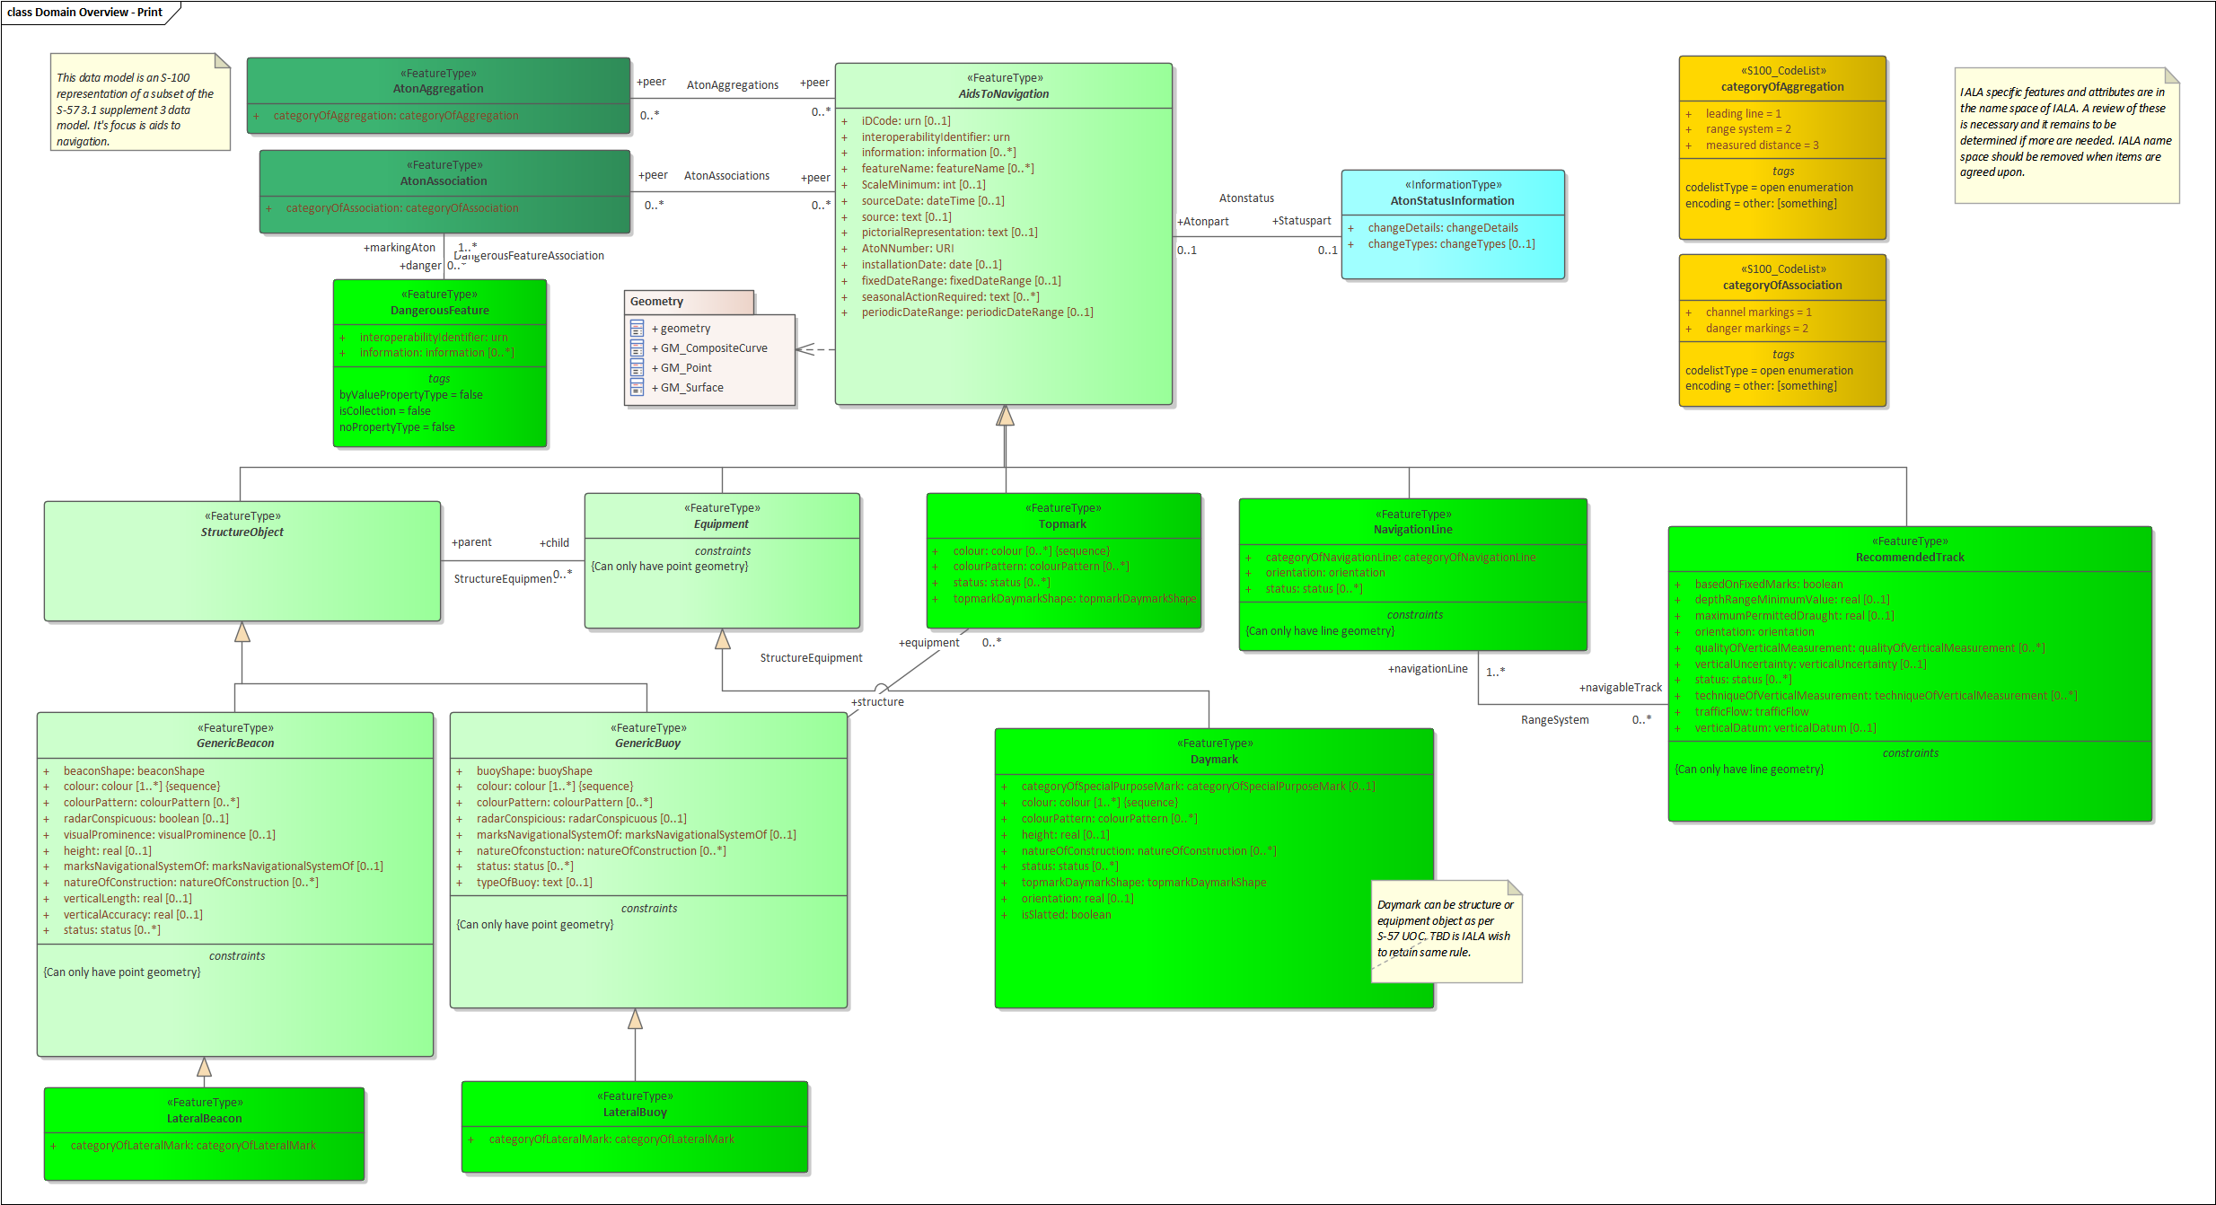
Figure 1. Overview of Feature types

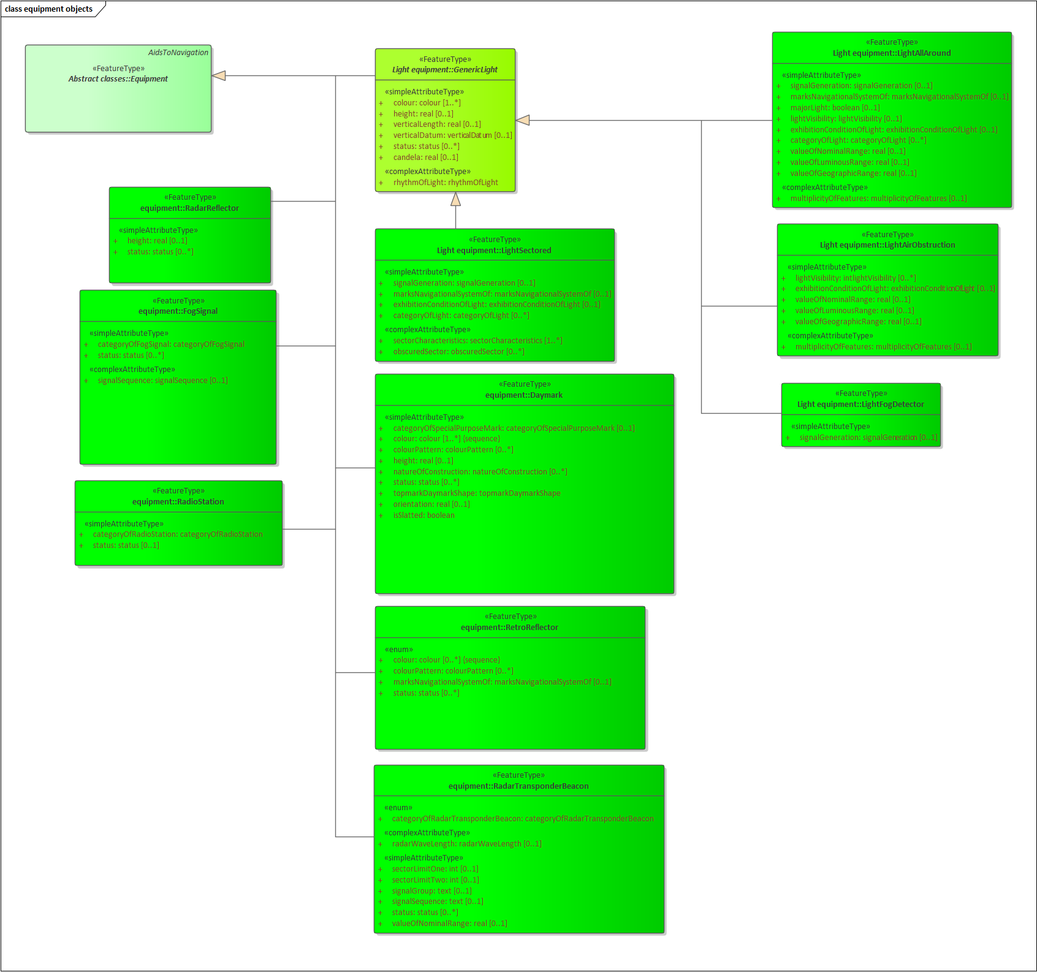
Figure 2. Equipment Feature Types

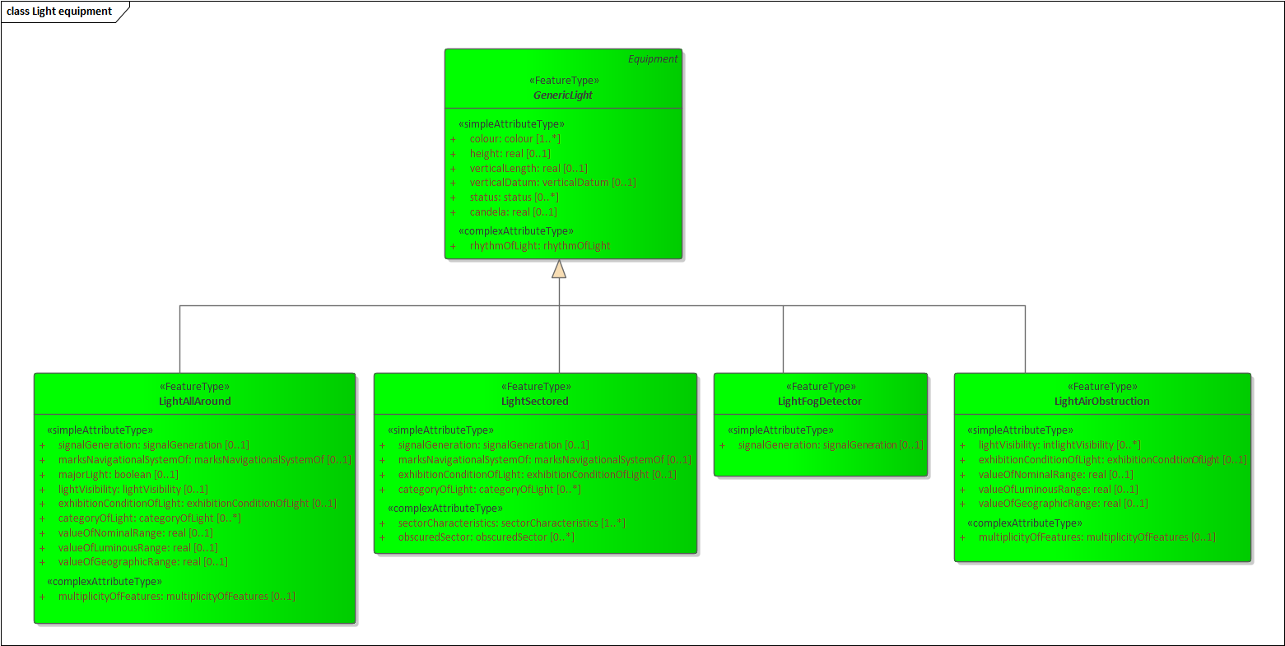
Figure 3. Light Feature Types

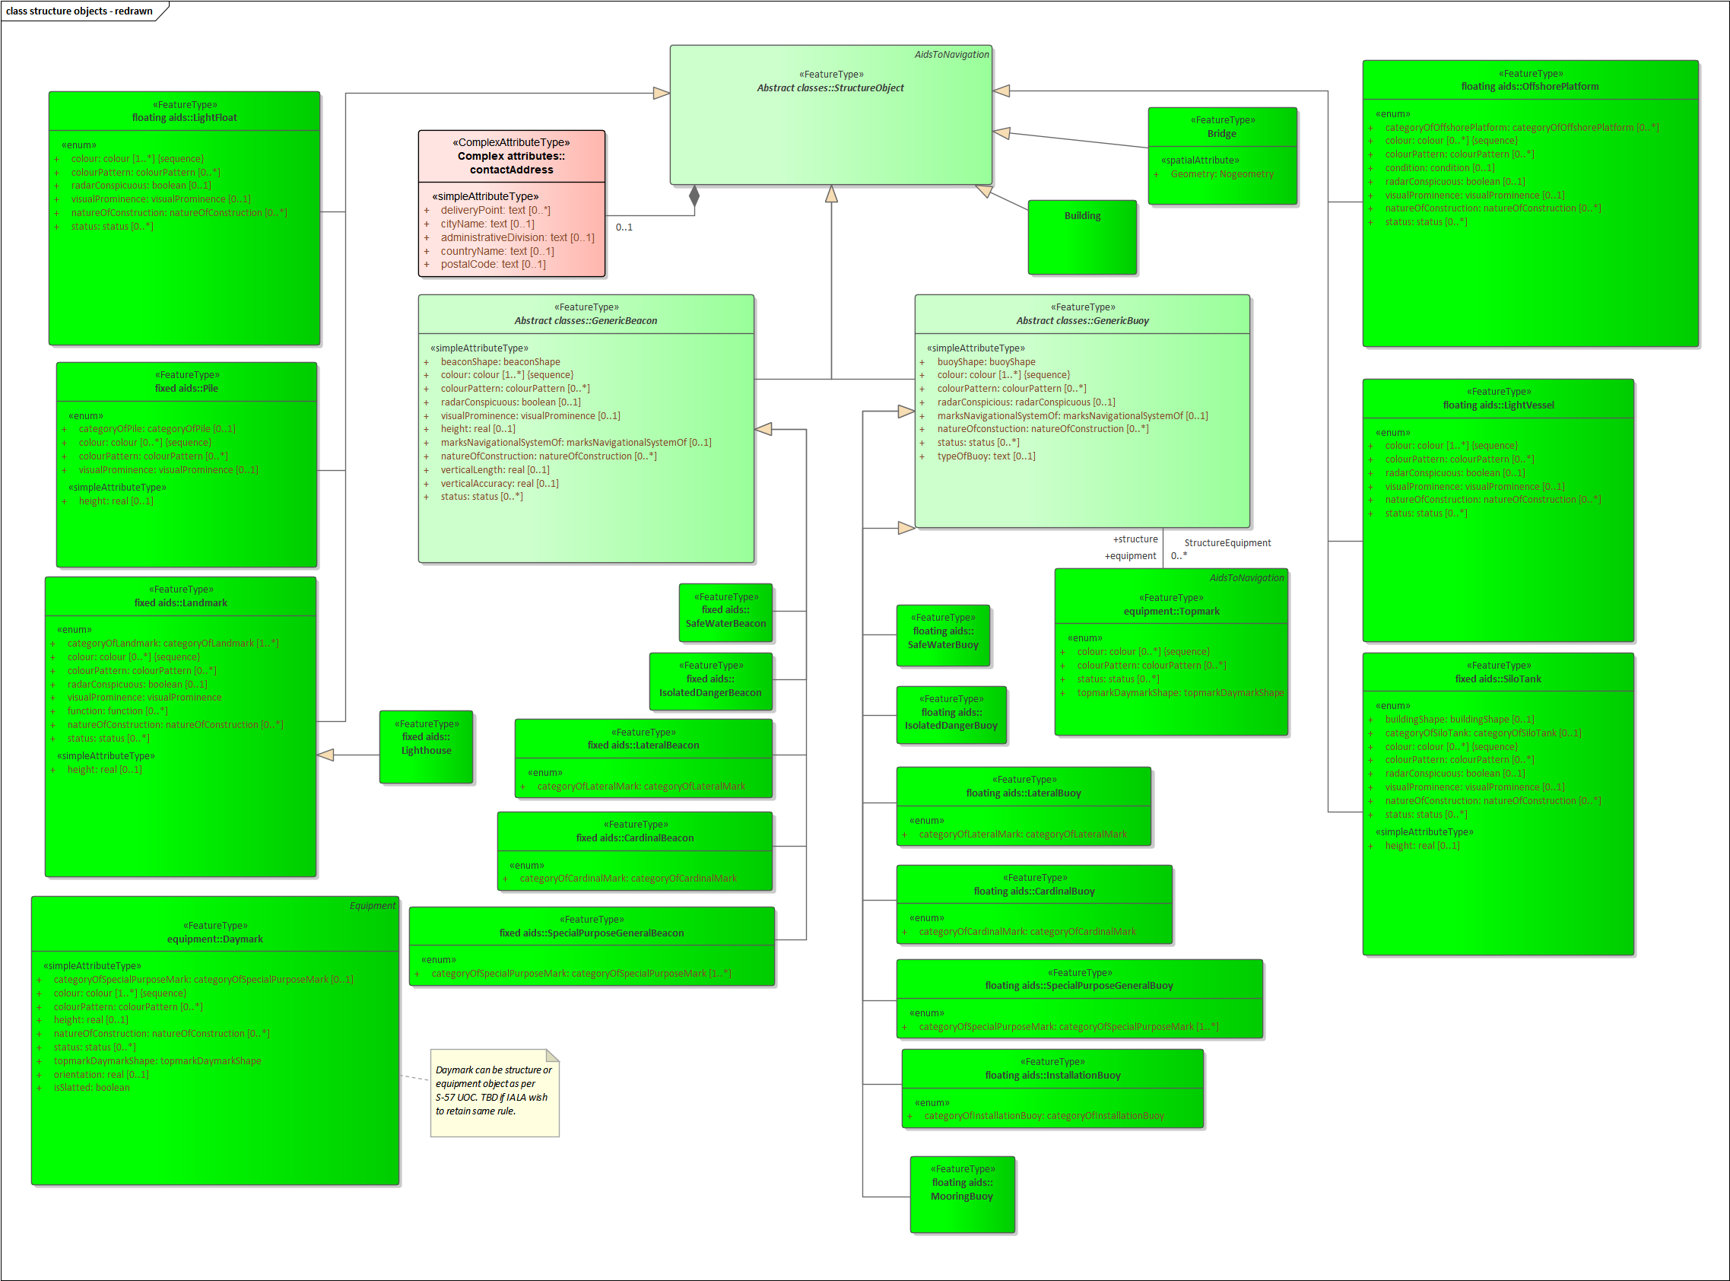
Figure 4. Structure Feature Types

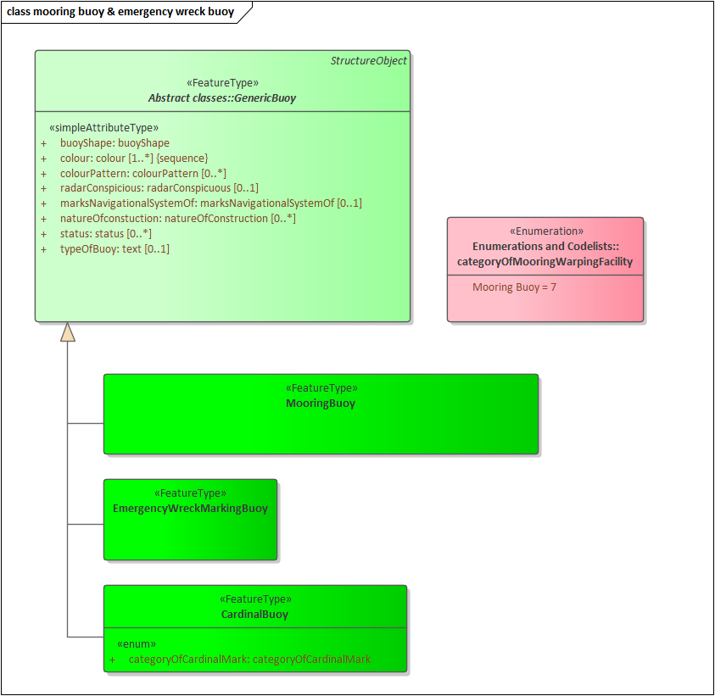
Figure 5. Mooring Buoy and Emergency Wreck Marking Buoy Feature Types

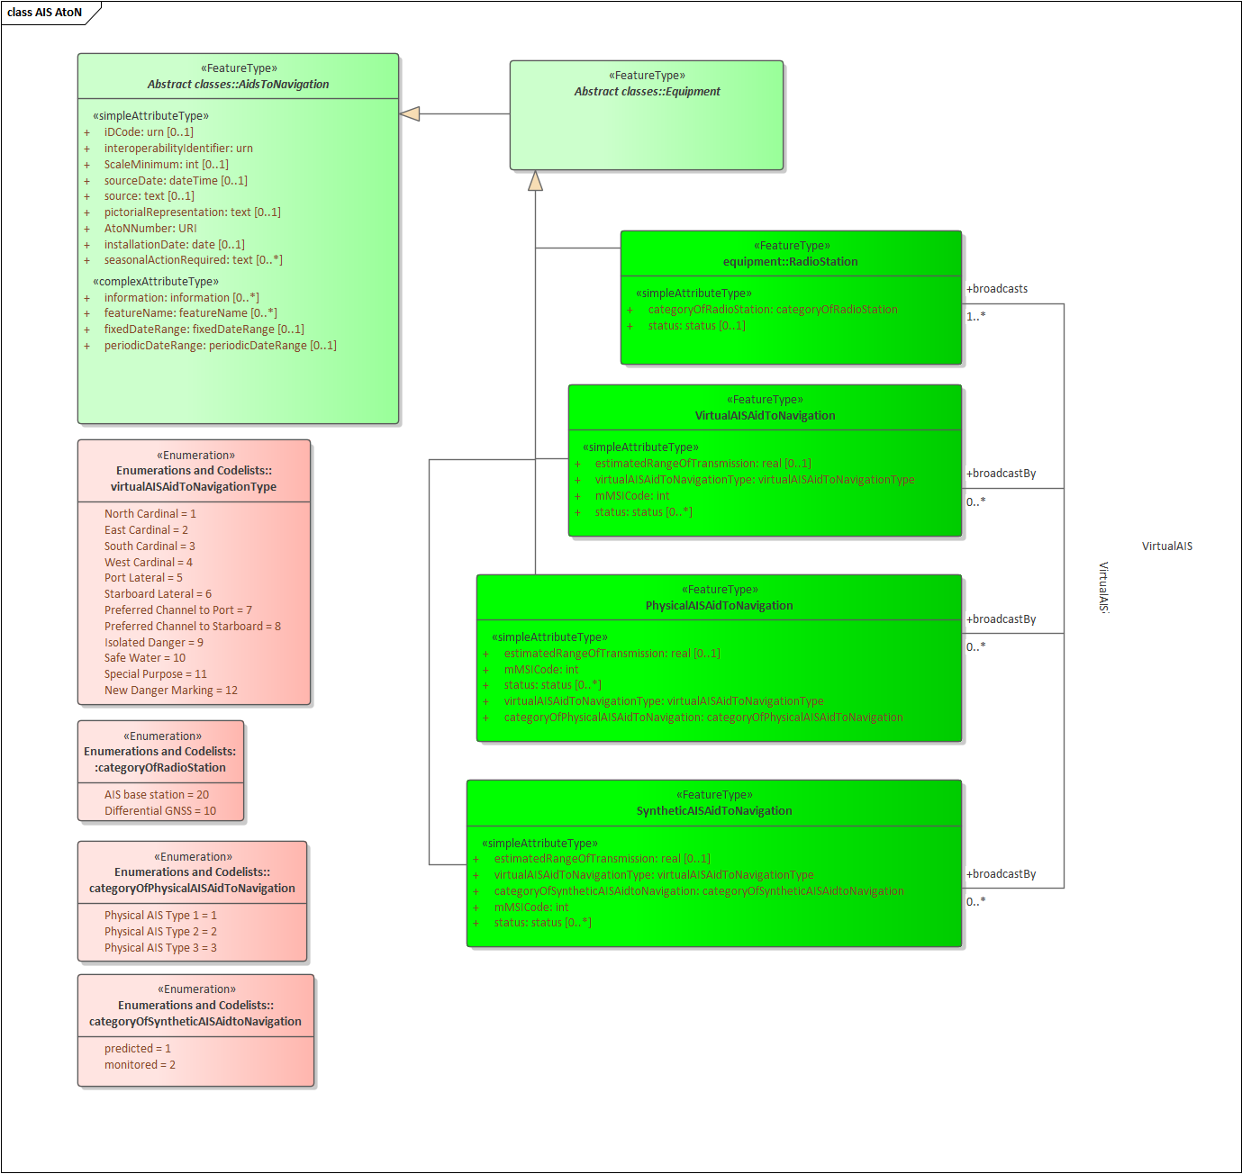
Figure 6. AIS Feature Types

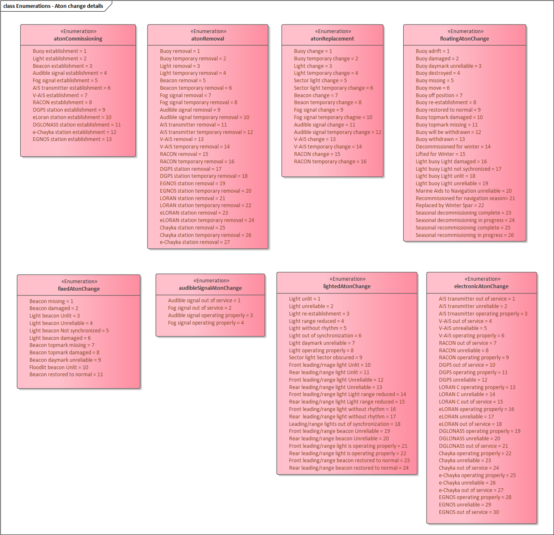
Figure 7. Aton change details Enumeration

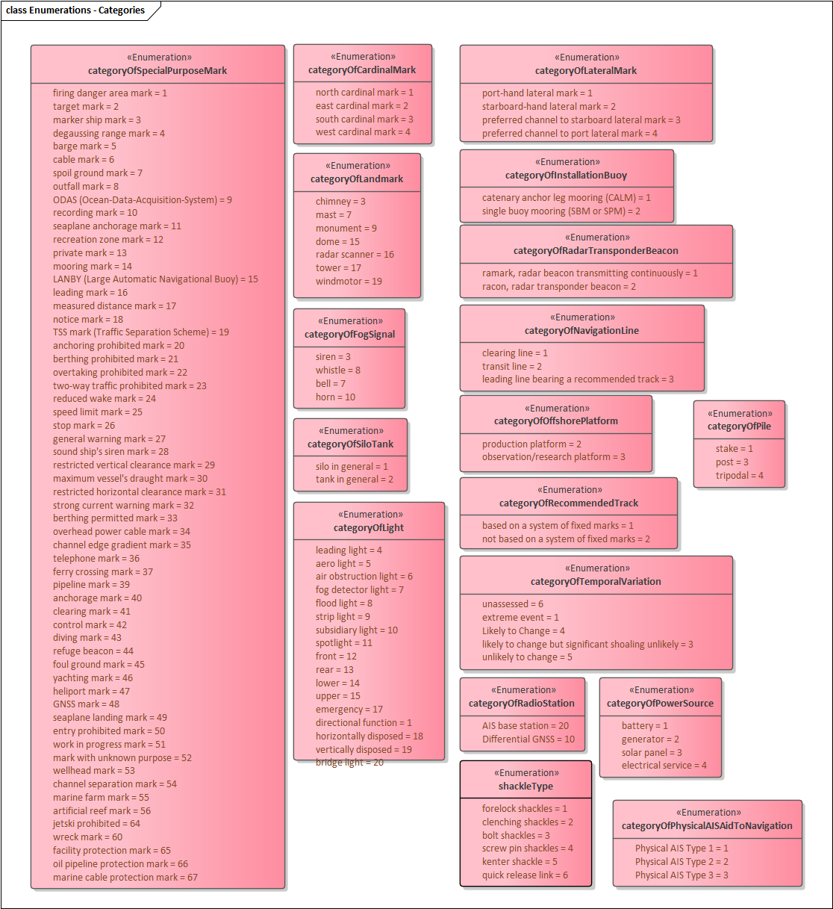
Figure 8. Categories Enumeration

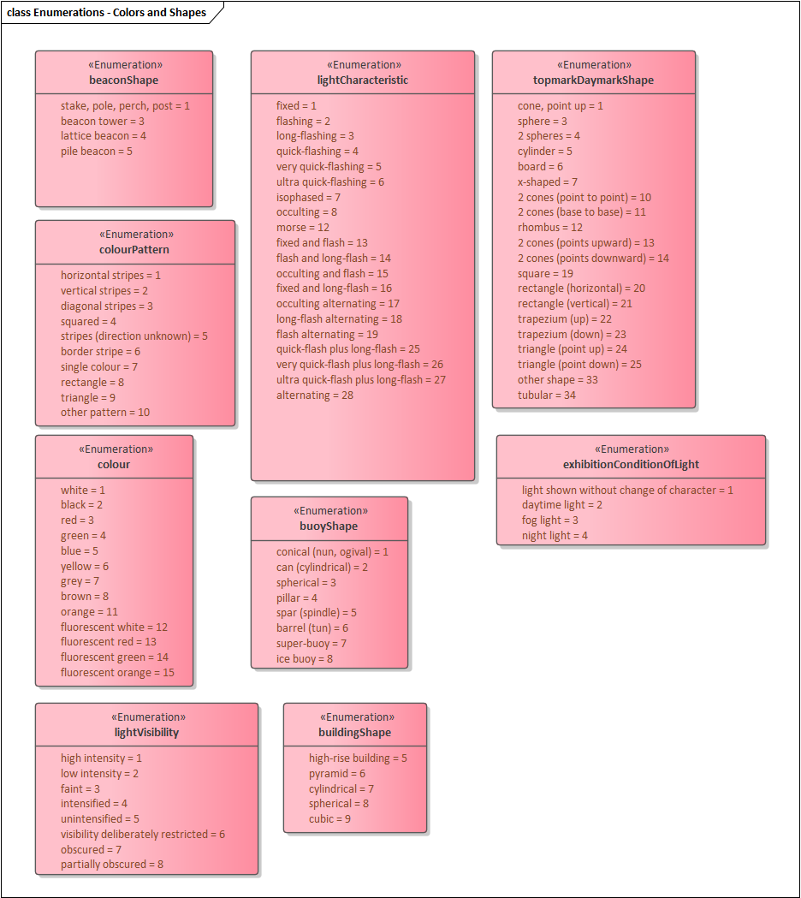
Figure 9. Colors and Shapes Enumeration

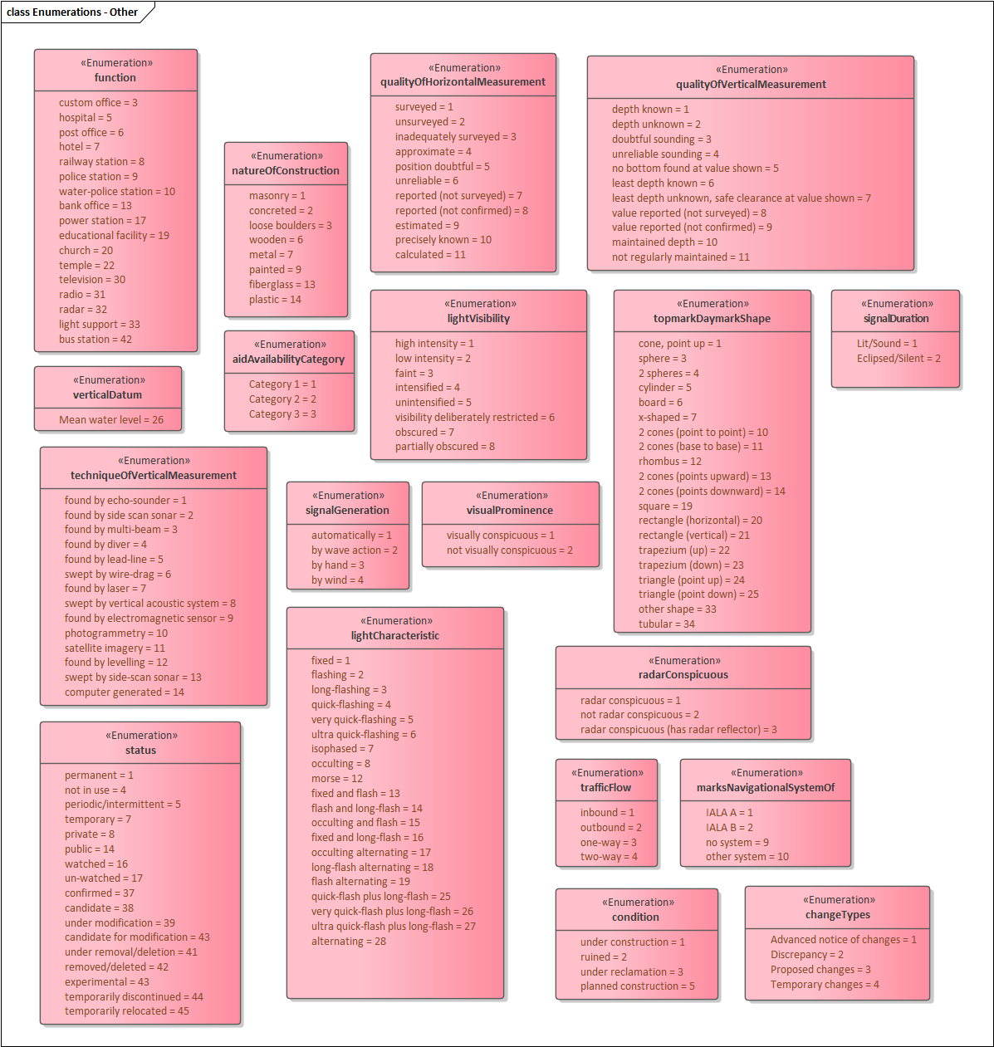
Figure 10. Others Enumeration

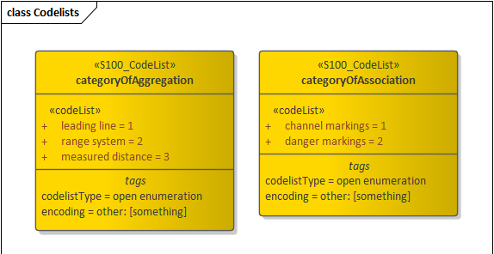
Figure 11. Code lists

Feature Catalogue

Introduction
The Feature Catalogue describes the feature types, information types, attributes, attribute values, associations and roles which may be used in the product. The S-125 Feature Catalogue is available in an XML document which conforms to the S-100 XML Feature Catalogue Schema and can be downloaded from the IHO website (https://iho.int). Simple attributes used in this specification are listed below.

Name: Marine Aids to Navigation (AtoN)
Scope: Ocean, Coastal, Ports, Harbors and Inland waters
Version Number: 0.0.4
Version Date: 2025-03-28
Producer: International Hydrographic Organization (IHO),
4 quai Antoine 1er,
B.P. 445
MC 98011 MONACO CEDEX
Telephone: +377 93 10 81 00
Telefax: + 377 93 10 81 40
URL https://iho.int
Language: English

Feature Types
Feature types contain descriptive attributes that characterize real-world entities. The word ‘feature’ may be used in one of two senses – feature type and feature instance. A feature type is a class and is defined in a Feature Catalogue. A feature instance is a single occurrence of the feature type and represented as an object in a dataset. A feature instance is located by a relationship to one or more spatial instances. A feature instance may exist without referencing a spatial instance.

Geographic
Geographic (Geo) feature types carry the descriptive characteristics of a real world entity.

Meta
Meta features contain information about other features within a data set. Information defined by meta features override the default metadata values defined by the data set descriptive records. Meta attribution on individual features overrides attribution on meta features.

Feature Relationship
A feature relationship links instances of one feature type with instances of the same or a different feature type.

Information Types
Information types are identifiable pieces of information in a dataset that can be shared between other features. They have attributes but have no relationship to any geometry; information types may reference other information types.

Attributes
S-125 defines attributes as either simple or complex.

Simple Attributes
S-125 uses ten types of simple attributes; they are listed in the Table below.

Type | Definition
Enumeration | A fixed list of valid identifiers of named literal values.
Boolean | A value representing binary logic. The value can be either True or False. The default state for Boolean type attributes (i.e. where the attribute is not populated for the feature) is False.
Real | A signed Real (floating point) number consisting of a mantissa and an exponent.
Integer | A signed integer number. The representation of an integer is encapsulation and usage dependent.
CharacterString | An arbitrary-length sequence of characters including accents and special characters from a repertoire of one of the adopted character sets.
Date | A date provides values for year, month, and day according to the Gregorian Calendar. Character encoding of a date is a string which must follow the calendar date format (complete representation, basic format) for date specified by ISO 8601:1988.  EXAMPLE 19980918 (YYYY-MM-DD)
Time | A time is given by an hour, minute, and second. Character encoding of a time is a string that follows the local time (complete representation, basic format) format defined in ISO 8601:1988.  EXAMPLE 183059 or 183059+0100 or 183059Z
Date and Time | A DateTime is a combination of a date and a time type. Character encoding of a DateTime shall follow ISO 8601:1988.  EXAMPLE 19850412T101530
Codelist | A type of flexible enumeration. A code list type is a list of literals which may be extended only in conformance with specified rules.
Truncated date | One or more components of the Date type are omitted.
Table 7-1. Simple feature attributes.

Complex Attributes
Complex attributes are aggregations of other attributes that are either simple or complex. The aggregation is defined by means of attribute bindings.
Figure 7-1. textContent – a complex attribute

Geometric Representation
Geometric representation is the digital description of the spatial component of an object as described in S-100 and ISO 19107. This product specification uses three types of geometries: GM_Point, GM_OrientableCurve, and GM_OrientableSurface.

Coordinate Reference System (CRS)

Introduction
The location of an object in the S-100 standard is defined by means of coordinates which relate a feature to a position. The coordinate reference system used for this product specification is World Geodetic System 1984 (WGS 84) which is defined by the European Petroleum Survey Group (EPSG) code 4326, (or similar - North American Datum 1983 / Canadian Spatial Reference System).

Spatial data is expressed as latitude (φ) and longitude (λ) geographic coordinates. Latitude values are stored as a negative number to represent a position south of the Equator. Longitude values are stored as a negative number to represent a position west of the International Prime Meridian. Coordinates are expressed as real value, degree / degree decimal format. Datasets conforming to this product specification are not projected.

Horizontal coordinate reference system: WGS 84
Projection: None
Vertical coordinate reference system: None

Temporal reference system: Gregorian calendar
Coordinate reference system registry: EPSG Geodetic Parameter Registry

Date type (according to ISO 19115): 002 - publication

Horizontal reference system

Positional data is expressed in latitude and longitude geographic coordinates of the World Geodetic System 84 (WGS 84).

Projection
Marine AtoN data products are un-projected.

Vertical coordinate reference system
Marine Aids to Navigation (AtoN) data products do not provide detailed vertical information.

Temporal reference system
Time is measured by reference to Calendar dates and Clock time in accordance with ISO 19108:2002 Temporal Schema clause 5.4.4.

Coverage of nautical products data and scale
Marine AtoN data must be compiled in the best applicable scale. The use of the data itself is "scale independent". That means that the data can be used at any scale. S-100 allows the association of multiple spatial attributes to a single feature instance. Each of these spatial attributes can in principle be qualified by maximum and minimum scales.
For example, it is possible, within one dataset, to have a single instance of a feature that has more than one area geometry. Each of these geometries has different scale max/min attributes. Moreover, due to cluttering in smaller scales, the scale minimum attribute may be used to turn off portrayal of some features at smaller scales.

Data Quality

Data quality allows users and user systems to assess fitness for use of the provided data. Data quality measures and the associated evaluation are reported as metadata of a data product. This metadata improves interoperability with other data products and provides usage by user groups that the data product was not originally intended for. The secondary users can make assessments of the data product usefulness in their application based on the reported data quality measures.
For S-125 the following data quality elements have been included:
- Conformance to this Product Specification;
- Intended purpose of the data product;
- Completeness of the data product in terms of coverage;
- Logical Consistency;
- Positional Uncertainty and Accuracy;
- Thematic Accuracy;
- Temporal Quality;
- Aggregation measures;
- Elements specifically required for the data product (none currently identified for S-125);
- Validation checks or conformance checks including:
  - General tests for dataset integrity;
  - Specific tests for a specific data model.

Data Capture and Classification

Data source: S-125 products must be based on data sources released by an appropriate authority such as AtoN authority and Hydrographic Offices. Data source must be described in each data product.
The production process used to generate Marine AtoN products may be described in the comment attribute of the dataset metadata.

Item Name | Description | Multiplicity | Type
dataSource | Identification of the kinds of data sources  usable to product datasets compliant with the  considering specification | 0..* | CharacterString
productionProcess | Link to a textual description of the production  process (including encoding guide)  applicable to the datasets compliant with the  considering specification | 0..* | CharacterString (URL)
Table 10-1. Data capture information

Data Encoding and Product Delivery

Data Encoding
The principal encoding will be the Open Geospatial Consortium (OGC), Geography Markup Language (GML) format. GML is an XML grammar designed to express geographical features. It serves as a modeling language for geographic systems as well as an open interchange format for geographic transactions.

Types of Datasets
A dataset is a grouping of features, attributes, geometry, and metadata which comprises a specific coverage. The following lists the types of Marine AtoN datasets which may be produced and contained within an exchange set:

Dataset | Explanations
New dataset (base dataset): | Data for an area different (in coverage and/or extent) to existing datasets.
New Edition of a dataset: | A re-issue plus new information which has not been previously distributed by Updates. Each New Edition of a dataset must have the same name as the dataset that it replaces and should have the same spatial extents. The edition number in the dataset discovery metadata shall increment up by one from the previous edition.
Update dataset | A data replacement of the latest edition of a dataset.
Cancellation | Used to cancel dataset and any related update datasets.
Table 10-2. Marine AtoN dataset types

Content of Update Datasets
Update datasets can only contain replacements, deletions, and additions of whole feature instances or information instances. This means that when a feature or information instance is updated, the new version must contain all the attributes of the old instance, including any inline spatial attributes (i.e., inline geometry), except those attributes that are being removed.

An association to an instance of a feature or information type is treated as an attribute of the referring instance, and therefore adding or deleting an association means the original referring instance must be replaced with a new version. The instance at the other end of the association needs to be replaced if and only if it contains a reference to the first instance.

Spatial objects that are not inline (i.e., geometry that is encoded as an independent spatial object in the dataset) are treated like any other object, i.e., it needs to be updated if and only if the primitive has changed (e.g., a coordinate is updated).

Feature and information type instances are deleted without replacement by setting the fixedDateRange.dateEnd attribute of the instance to the date of deletion, which will usually be the issue date of the update.

Encoding of Latitude and Longitude
Values of latitude and longitude must not be more accurate than 7 decimal places. Coordinates must be encoded as decimals in the format described in Clause 10.2.1.
Values should be coded as decimal numbers with 7 or fewer digits after the decimal. The normative encoding is in degrees, with an accuracy of 10⁻⁷ degrees, i.e., 7 digits after the decimal point.
The decimal point must be indicated by the “.” character.
Trailing zeroes after the decimal point (and the decimal point itself if appropriate) may be omitted at producer discretion, but the accuracy must still be as indicated (e.g., 10⁻⁷ degrees for coordinates of default accuracy).

Numeric Attribute Encoding
Floating point and integer attribute values must not contain leading zeros. Floating point attribute values must not contain non-significant trailing zeros.

Text Attribute Values
Character strings must be encoded using the character set defined in ISO 10646-1, in Unicode Transformation Format-8 (UTF-8).

Mandatory Attribute Values
There are four reasons why attribute values may be considered mandatory:
- They determine whether a feature is in the display base.
- Certain features make no logical sense without specific attributes.
- Some attributes are necessary to determine which symbol is to be displayed.
- Some attributes are required for safety of navigation.
All mandatory attributes are identified in the Feature Catalogue and summarized in Annex A – Data Classification and Encoding Guide.

Unknown Attribute Values
When a mandatory attribute code or tag is present but the attribute value is missing, it means that the producer wishes to indicate that this attribute value is unknown. Missing mandatory attributes must be “nilled”.
Optional attributes must be omitted altogether if the value is unknown or missing. They must not be “nilled.”

EXAMPLE A landmark feature has unknown category of landmark (mandatory attribute) and function (optional attribute). The feature could be coded as:

<Landmark>
<categoryOfLandmark xsi:nil="true"/>
<function>radio</function>
… other attributes…
… <status> is NOT coded …
<Landmark>

Structure of dataset files
The order of data objects in each dataset file is described below:

Dataset Identification Information
Dataset structure information
Spatial records for by-reference geometries
Point
Curve
Composite Curve
Information objects
Feature objects (Geometry may be encoded inline or by reference.)
Meta features
Geo features

Object identifiers
The “name” of feature records must provide a unique world-wide identifier of feature records. The “name” of the record is the combination of the subfields agency, featureObjectIdentifier, and featureIdentificationSubdivision elements of the featureObjectIdentifier element of the object.

Features, information types, collection objects, meta features, and geometries (inline or external) are all required by the schema to have a gml:id attribute with a value that is unique within the dataset. The gml:id values must be used as the reference for the object from another object in the same dataset or another dataset.

Data coverage
All areas of a dataset must be covered by a DataCoverage meta feature.

An update dataset must not change the limit of a Data Coverage feature for the base dataset. Where the limit of a Data Coverage feature for a base dataset is to be changed, this must be done by issuing a new edition of the dataset.

Data overlap
S-125 datasets can overlap other S-125 datasets.

Data extent
Datasets must not cross the 180° meridian of longitude.

Data Delivery

Data Product Delivery Information
This data product specification defines GML as the primary format in which Marine AtoN data products are delivered. The delivery format is described by the following items (from ISO 19131:2005): format name, version, specification, language, and character set.

Name | ISO 19131 Elements | Value
Format name | DPS_DeliveryInformation.deliveryFormat > DPS_DeliveryFormat.formatName | GML*
Version | DPS_DeliveryInformation.deliveryFormat > DPS_DeliveryFormat.version | 3.2.1
Specification description | DPS_DeliveryInformation.deliveryFormat > DPS_DeliveryFormat.specification | GML*
Language | DPS_DeliveryInformation.deliveryFormat > DPS_DeliveryFormat.language | English
Character set | DPS_DeliveryInformation.deliveryFormat > DPS_DeliveryFormat.characterSet > MD_CharacterSetCode | 004 – utf8
Table 11-1. Data product delivery format
* GML is an XML encoding for the transport and storage of geographic information, including both the geometry and the properties of geographic features, between distributed systems. The XML Schema for the GML application schema is provided in a schema document S125.xsd which imports other schema(s) defining common types. (All files are available on the S-100 distribution site https://github.com/IHO-S100WG). Feature instance shall validate against S125.xsd and conform to all other requirements specified in this data product specification including all constraints not captured in the XML Schema document.

Dataset loading
New datasets must always replace old datasets.

Datasets must always be loaded in the order of base dataset first, then update datasets in the corrected sequential order. Systems are not to load updates out of order, for example if update 1-5 is present and update 1-6 is missing, update 1-7 must not be loaded.

New editions
When a new edition of a dataset is received, the system must replace the previous edition, along with any updates, with the new edition of the dataset. Loading of subsequent updates follows the same rule as above.

Dataset size
Marine AtoN datasets must not exceed 20MB.

Exchange Set
Data which conforms to this product specification must be delivered by means of an exchange set. An exchange set will consist of one or more Marine AtoN datasets. An exchange set may also include one or more support files containing supplementary information encoded in separate files. These are linked to the Marine AtoN dataset features, by feature and information type attributes defined in the application schema, e.g., fileReference. Each exchange set will include a single (XML) catalogue file. S-125 exchange set catalogues conform to S-100 4.0.0 Figure 4a-D-2 without modification, containing discovery metadata for each Marine AtoN dataset as well as support files. S-125 exchange set structure conforms to S-100 4.0.0 Figure 4a-D-3 without modification.

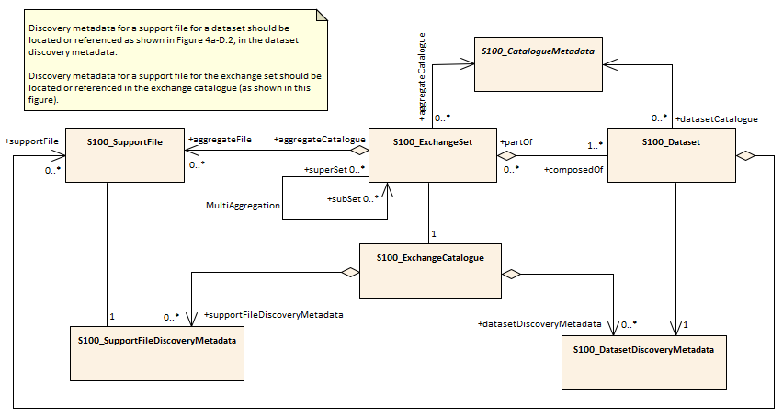
Figure 11-1. Exchange set structure

Support Files
Support files contain ancillary textual or graphic information in separate (linked to the dataset) files. The following formats are allowed for support files:

- Plain text files must contain only general text as defined in this standard. Files must use the UTF-8 character set encoding.
- HTML and XML files must contain only text and markup as defined in the relevant W3C standards. Files must use the UTF-8 character set encoding. References in datasets to HTML and XML support files must treat them as text files (i.e., they should not be referenced using attributes intended for picture files).
- Picture files must be in the Tagged Image file Format (TIFF) [Edition 6.0].

Support files shall be used for data management and additional information to users. Portraying and using support files in ECDIS or other systems is not mandatory. Table 11.2 describes the constraints on support file formats and provides the corresponding file extensions.

File type | Extension | Description
Text | TXT
 | HTM | HTML files must only include inline or embedded Cascading Style Sheet (CSS) information and must not contain embedded Javascript or other dynamic content, for example DHTML, Flash etc.
 | XML | XML documents must only be included in accordance with guidance provided within the Data Classification and Encoding Guide (Annex A) and must not contain embedded Javascript or other dynamic content.
Picture | TIF | Baseline TIFF 6.0.
Table 11-2. Support file formats and extensions

Support File Naming Convention

All support files will have unique world-wide file identifiers. The file identifier of support information should not be used to describe the physical content of the file. The support file metadata that accompanies the file will inform the user of the name and purpose of the file (new, replacement, and deletion).

In this encoding the support files are named according to the specifications given below:

125CCCCXXXXXXXXXX.YYY

The main part forms an identifier where:
- The first three characters are always “125” and identify the dataset as an S-125 dataset.
- The next four characters identify the issuing agency by its alphanumeric agency code in the IHO producer code register in the IHO GI Registry (i.e., the IHO is identified as “AA”, not “1810”). Where the agency code consists of fewer than four characters, sufficient zeros must be suffixed to make the length exactly four characters (e.g., “AA00” for IHO).
- The eighth up to the seventeenth character can be used in any way by the producer to provide a unique file name for the dataset. The following characters are allowed in the dataset name. A to Z, 0 to 9, and the special character _ (underscore). The ninth through seventeenth characters are optional (i.e., at least one character must be used).
- .YYY – support file extension. The YYY portion must conform to the file format as described in Table 11.2.

Dataset Naming Convention
All dataset files will have unique world-wide file identifiers. The file identifier of the dataset should not be used to describe the physical content of the file. The dataset file metadata that accompanies the file will inform the user of the name and purpose of the file (new, replacement, and deletion).
In this encoding the dataset files are named according to the specifications given below:

125CCCCXXXXXXXXXX.GML

The main part forms an identifier where:
- The first three characters are always “125” and identify the dataset as an S-125 dataset.
- The next four characters identify the issuing agency by its alphanumeric agency code in the IHO producer code register in the IHO GI Registry (i.e., the IHO is identified as “AA”, not “1810”). Where the agency code consists of fewer than four characters, sufficient zeros must be suffixed to make the length exactly four characters (e.g., “AA00” for IHO).
- The eighth up to the seventeenth character can be used in any way by the producer to provide a unique file name for the dataset. The following characters are allowed in the dataset name, A to Z, 0 to 9 and the special character _ (underscore). The ninth through seventeenth characters are optional (i.e., at least one character must be used).

Update dataset naming convention
All update dataset files will have an identical name to the base dataset, aside from the separator and update number sequence.

In this encoding the update dataset files are named according to the specifications given below:

125CCCCXXXXXXXXXX_XXX.GML

The main part forms an identifier where:

- The first up to the seventeenth characters are the same as the dataset being updated and therefore conform to the rules described in clause 11.6.
- The next character must be an underscore “_”.
- The next three characters must be numerical (0-9) characters to indicate the place of the update dataset in the update sequence.

Catalogue File Naming Convention
The exchange catalogue acts as the table of contents for the exchange set. The catalogue file of the exchange set must be named CATALOG.XML. No other file in the exchange set may be named CATALOG.XML. The content of the exchange catalogue file is described in Clause 14.

Dataset Maintenance

Introduction
Datasets are maintained as needed and must include mechanisms for Marine AtoN updating. Data updates will be made by new editions or updates. The maintenance and update frequency of Marine AtoN datasets should be defined by the producers (official national authority) implementing this specification.
Data Producers must use applicable sources to maintain and update data and provide a brief description of the sources that were used to produce the dataset in the appropriate metadata field.

Production process for base and update datasets
Data Producers should follow their established production processes for maintaining and updating datasets. Data is produced against the DCEG and checked against the appropriate set of validation rules in Appendix X.

Dataset updates and cancellation
The purpose of issue of the dataset is indicated in the “purpose” field of the dataset discovery metadata. In order to terminate a dataset, an update dataset file is created for which the edition number must be set to 0. This convention is only used to cancel a base dataset file.

Where a dataset is cancelled and its name is reused at a later date, the issue date must be greater than the issue date of the cancelled dataset.

When the dataset is cancelled, it must be removed from the system.

An exchange set may contain base dataset files and update dataset files for the same datasets. Under these circumstances the update dataset files must follow in the correct sequential order from the last update applied to the base dataset file.

Support file updates
The purpose of issue is indicated in the “purpose” field of the support file discovery metadata. Support files carrying the “deletion” flag in metadata must be removed from the system. When a feature or information type pointing to a text, picture, or application file is deleted or updated so that it no longer references the file, the system software must check to see whether any other feature or information type references the same file, before that file is deleted.

Updates, in form of a new edition or a replacement, or deletions of a support file may require concurrent updates to feature or information type instance attributes that depend on the file, e.g., pictorialRepresentation, fileReference, and fileLocator attributes.

Feature and portrayal catalogues
For each new version of the S-125 Product Specification a new feature and portrayal catalogue may be released. The system must be able to manage datasets and their catalogues that are created on different versions of the S-125 product specification.

Feature history, versions, and change tracking
If applications or production systems require versioning of individual instances of feature or information types, maintenance of histories, or change tracking, the methods for versioning, history management, and change tracking and display are left to the application or production system.

Dataset encryption
Details about dataset encryption are still to be determined, and may mirror the method described in S-101.

Portrayal
Portrayal is not defined in this version of S-125 Marine Aids to Navigation (AtoN) Product Specifications. Users are free to choose the means and methodology of portrayal as they see best suited for their needs. It should be noted that future versions of S-125 may include a portrayal catalogue, and any implementer should therefore anticipate this, and make sufficient provisions in any system supporting S-125.

Metadata

Introduction
The Marine AtoN metadata specification conforms to the S-100 metadata specification in Part 4a, which is a profile of the ISO 19115-1 standard. These documents provide a structure for describing digital geographic data and define metadata elements, a common set of metadata terminology, definitions, and extension procedures.

The overall structure of metadata in S-125 exchange sets is the same as in S-100, and is depicted in Figure 14.1. Metadata in exchange sets consists of discovery metadata for the datasets and support files in the exchange set (classes S100_DatasetDiscoveryMetadata and S100_SupportFileDiscoveryMetadata), metadata in ISO 19115-1 format for datasets, and metadata about any feature, portrayal, or interoperability catalogues which are in the exchange set (S100_CatalogueMetadata).

The discovery metadata classes have numerous attributes which enable important information about the datasets and accompanying support files to be examined without the need to process the data, for example decrypt, decompress, load, etc. Other catalogues such as feature and portrayal catalogues can be included in the exchange set in support of the datasets.

More detailed information for the classes is depicted in Figure 14.2 and details about the metadata classes are provided in Clauses 14.2–14.5.

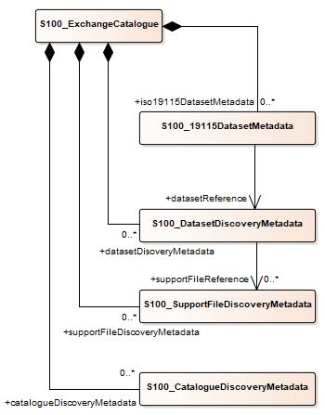
Figure 14-1. Metadata in exchange catalogue

ISO 19115 metadata conforms to ISO 19115 with the additional constraints in S-100 Part 4A Appendix 4A-B.1 (Table B.1) which make the fileIdentifier element mandatory

Metadata classes
Details for the S-100 metadata classes are depicted in the figure below.

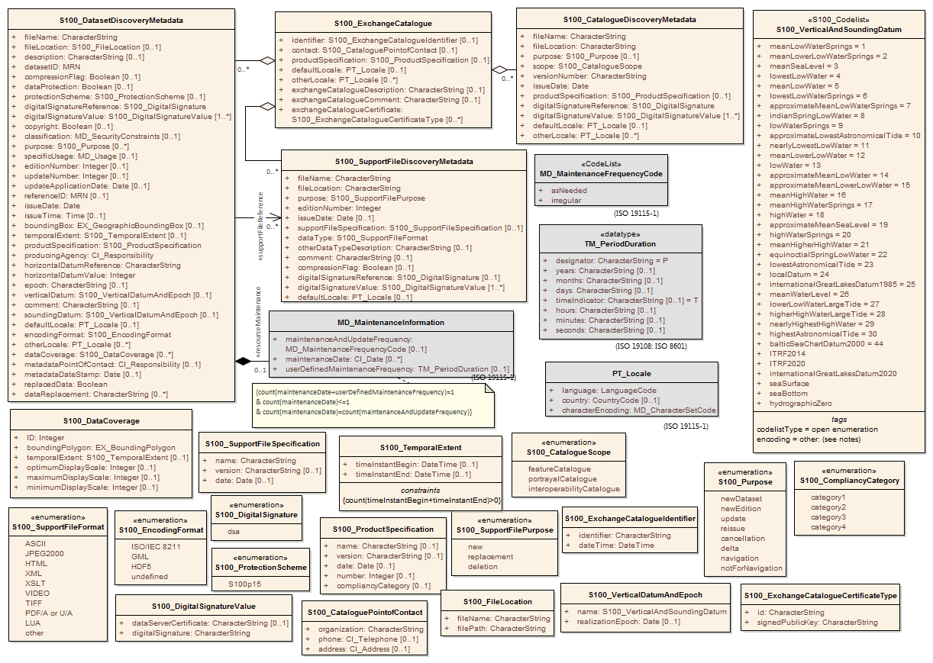
Figure 13. S-100 metadata class details

S100_ExchangeCatalogue

Each Exchange Set has a single S100_ExchangeCatalogue which contains meta information for the data and support files in the Exchange Set.
Role Name | Name | Description | Mult | Type | Remarks
Class | S100_ExchangeCatalogue | An Exchange Catalogue contains the discovery metadata about the exchange datasets and support files | - | - | -
Attribute | identifier | Uniquely identifies this Exchange Catalogue | 0..1 | S100_ExchangeCatalogueIdentifier
Attribute | contact | Details about the issuer of this Exchange Catalogue | 0..1 | S100_CataloguePointOfContact
Attribute | productSpecification | Details about the Product Specifications used for the datasets contained in the Exchange Catalogue | 0..* | S100_ProductSpecification
Attribute | defaultLocale | Default language and character set used for all metadata records in this Exchange Catalogue | 0..1 | PT_Locale | Default is English and UTF-8
Attribute | otherLocale | Other languages and character sets used for the localized metadata records in this Exchange Catalogue | 0..* | PT_Locale | Required if any localized entries are present in the Exchange Catalogue
Attribute | exchangeCatalogueDescription | Description of what the Exchange Catalogue contains | 0..1 | CharacterString
Attribute | exchangeCatalogueComment | Any additional Information | 0..1 | CharacterString
Attribute | certificates | Signed public key certificates referred to by digital signatures in the Exchange Set | 0..* | S100_SE_CertificateContainer | Content defined in S-100 Part 15. All certificates used, except the SA root certificate (installed separately by the implementing system) shall be included
Attribute | dataServerIdentifier | Identifies the data server for the permit | 0..1 | CharacterString
Role | datasetDiscoveryMetadata | Exchange Catalogues may include or reference discovery metadata for the datasets in the Exchange Set | 0..* | Aggregation S100_DatasetDiscoveryMetadata
Role | catalogueDiscoveryMetadata | Metadata for Catalogue | 0..* | Aggregation S100_CatalogueDiscoveryMetadata | Metadata for the Feature, Portrayal and Interoperability Catalogues, if any
Role | supportFileDiscoveryMetadata | Exchange Catalogues may include or reference discovery metadata for the support files in the Exchange Set | 0..* | Aggregation S100_SupportFileDiscoveryMetadata

S100_ExchangeCatalogueIdentifier
Role Name | Name | Description | Mult | Type | Remarks
Class | S100_ExchangeCatalogueIdentifier | An identifier for an Exchange Catalogue . | - | - | The concatenation of identifier, editionNumber and dateTime form the unique name
Attribute | identifier | Uniquely identifies this Exchange Catalogue | 1 | CharacterString | <S100XC:identifier>US_101_20200101_120101_01</S100XC:identifier>
Attribute | dateTime | Creation date and time of the Exchange Catalogue, including time zone | 1 | DateTime | Format: yyyymmddThhmmssZ

S100_CataloguePointofContact
Role Name | Name | Description | Mult | Type | Remarks
Class | S100_CataloguePointOfContact | Contact details of the issuer of this Exchange Catalogue | - | - | -
Attribute | organization | The organization distributing this Exchange Catalogue | 1 | CharacterString | This could be an individual producer, value added reseller, etc
Attribute | phone | The phone number of the organization | 0..1 | CI_Telephone
Attribute | address | The address of the organization | 0..1 | CI_Address

S100_DatasetDiscoveryMetadata
Role Name | Name | Description | Mult | Type | Remarks
Class | S100_DatasetDiscoveryMetadata | Metadata about the individual datasets in the Exchange Catalogue | - | - | -
Attribute | fileName | Dataset file name | 1 | CharacterString
Attribute | fileLocation | Relative location from the Exchange Set root directory | 1 | CharacterString | Path relative to the root directory of the Exchange Set. The location of the file after the Exchange Set is unpacked into a directory <ROOT> will be <ROOT>/S100_ROOT/<fileLocation>/<filename>
Attribute | description | Short description giving the area or location covered by the dataset | 0..1 | CharacterString | For example, a harbour or port name, between two named locations etc
Attribute | datasetID | Dataset ID expressed as a Marine Resource Name | 0..1 | URN | The URN must be an MRN
Attribute | compressionFlag | Indicates if the resource is compressed | 1 | Boolean | True indicates a compressed dataset resource  False indicates an uncompressed dataset resource
Attribute | dataProtection | Indicates if the data is encrypted | 1 | Boolean | True indicates an encrypted dataset resource  False indicates an unencrypted dataset resources
Attribute | protectionScheme | Specification of method used for data protection | 0..1 | S100_ProtectionScheme
Attribute | digitalSignatureReference | Specifies the algorithm used to compute digitalSignatureValue | 1 | S100_DigitalSignatureReference  (see Part 15)
Attribute | digitalSignatureValue | Value derived from the digital signature | 1..* | S100_DigitalSignatureValue  (see Part 15) | The value resulting from application of digitalSignatureReference  Implemented as the digital signature format specified in Part 15
Attribute | copyright | Indicates if the dataset is copyrighted | 1 | Boolean | True indicates the resource is copyrighted  False Indicates the resource is not copyrighted
Attribute | classification | Indicates the security classification of the dataset | 0..1 | Class MD_SecurityConstraints>MD_ClassificationCode (codelist) | 1. unclassified  2. restricted  3. confidential  4. secret  5. top secret  6. sensitive but unclassified  7. for official use only  8. protected  9. limited distribution
Attribute | purpose | The purpose for which the dataset has been issued | 0..1 | S100_Purpose
Attribute | notForNavigation | Indicates the dataset is not intended to be used for navigation | 1 | Boolean | True indicates the dataset is not intended to be used for navigation  False indicates the dataset is intended to be used for navigation
Attribute | specificUsage | The use for which the dataset is intended | 0..1 | MD_USAGE>specificUsage (character string)
Attribute | editionNumber | The Edition number of the dataset | 0..1 | Integer | When a data set is initially created, the Edition number 1 is assigned to it. The Edition number is increased by 1 at each new Edition. Edition number remains the same for a re-issue
Attribute | updateNumber | Update number assigned to the dataset and increased by one for each subsequent update | 0..1 | Integer | Update number 0 is assigned to a new dataset
Attribute | updateApplicationDate | This date is only used for the base cell files (that is new data set, re-issue and new edition), not update cell files. All updates dated on or before this date must have been applied by the producer | 0..1 | Date
Attribute | referenceID | Reference back to the datasetID | 0..1 | URN | Update metadata refers to the datasetID of the dataset metadata. This is used if and only if the dataset is an update  The URN must be an MRN
Attribute | issueDate | Date on which the data was made available by the Data Producer | 1 | Date
Attribute | issueTime | Time of day at which the data was made available by the Data Producer | 0..1 | Time | The S-100 datatype Time
Attribute | boundingBox | The extent of the dataset limits | 0..1 | EX_GeographicBoundingBox | -
Attribute | temporalExtent | Specification of the temporal extent of the dataset. | 0..1 | S100_TemporalExtent | The temporal extent is encoded as the date/time of the earliest and latest data records (in coverage datasets) or date/time ranges (in vector datasets)  If there is more than one feature in a dataset, the earliest and latest time values of records in all features are used, which means the earliest and latest values may be from different features  If date/time information for a feature is not encoded in the dataset, it is treated for the purposes of this attribute as extending indefinitely in the appropriate direction on the time axis, limited by the issue date/time or the cancellation or supersession of the dataset  This attribute is encoded if and only if at least one of the start and end of the temporal extent is known
Attribute | productSpecification | The Product Specification used to create this dataset | 1 | S100_ProductSpecification
Attribute | producingAgency | Agency responsible for producing the data | 1 | CI_Responsibility>CI_Organisation | See Table 17-3
Attribute | producerCode | The official IHO Producer Code from S-62 | 0..1 | CharacterString
Attribute | encodingFormat | The encoding format of the dataset | 1 | S100_EncodingFormat
Attribute | dataCoverage | Provides information about data coverages within the dataset | 0..* | S100_DataCoverage
Attribute | comment | Any additional information | 0..1 | CharacterString
Attribute | defaultLocale | Default language and character set used in the dataset | 0..1 | PT_Locale | In absence of defaultLocale the language is English, UTF-8
Attribute | otherLocale | Other languages and character sets used in the dataset | 0..* | PT_Locale
Attribute | metadataPointOfContact | Point of contact for metadata | 0..1 | CI_Responsibility>CI_Individual or  CI_Responsibility>CI_Organisation | Only if metadataPointOfContact is different to producingAgency
Attribute | metadataDateStamp | Date stamp for metadata | 0..1 | Date | May or may not be the issue date
Attribute | replacedData | If a data file is cancelled is it replaced by another data file | 0..1 | Boolean
Attribute | dataReplacement | Cell name | 0..* | CharacterString | A dataset may be replaced by 1 or more datasets
Attribute | navigationPurpose | Classification of intended navigation purpose (for Catalogue indexing purposes) | 0..3 | S100_NavigationPurpose | If Product Specification is intended for creation of navigational products this attribute should be mandatory
Role | resourceMaintenance | Information about the frequency of resource updates, and the scope of those updates | 0..1 | MD_MaintenanceInformation | S-100 restricts the multiplicity to 0..1 and adds specific restrictions on the ISO 19115 structure and content. See clause MD_MaintenanceInformation later in this Part  Format: PnYnMnDTnHnMnS (XML built-in type for ISO 8601 duration). See Notes

S100_NavigationPurpose
Role Name | Name | Description | Code | Remarks
Enumeration | S100_NavigationPurpose | The purpose of the dataset | -
Value | port | For port and near shore operations | 1 | -
Value | transit | For coast and planning purposes | 2 | -
Value | overview | For ocean crossing and planning purposes | 3 | -

S100_DataCoverage
Role Name | Name | Description | Mult | Type | Remarks
Class | S100_DataCoverage | A spatial extent where data is provided; and the display scale information for the provided data | - | - | This field is used by user systems as part of the data loading and unloading algorithms and it is strongly encouraged that Product Specifications mandate the use of one or more of the displayScale provided as part of S100_DataCoverage
Attribute | boundingPolygon | A polygon which defines the actual data limit | 1..1 | EX_BoundingPolygon
Attribute | temporalExtent | Specification of the temporal extent of the coverage | 0..1 | S100_TemporalExtent | The remarks for temporalExtent in the dataset discovery block (S100_DatasetDiscoveryMetadata) apply, except that their scope is the individual coverage and not the dataset as a whole
Attribute | optimumDisplayScale | The scale with which the data is optimally displayed | 0..1 | Integer | Example: A scale of 1:25000 is encoded as 25000
Attribute | maximumDisplayScale | The maximum scale with which the data is displayed | 0..1 | Integer
Attribute | minimumDisplayScale | The minimum scale with which the data is displayed | 0..1 | Integer
Attribute | approximateGridResolution | The resolution of gridded or georeferenced data (in metres) | 0..* | Real | A single value may be provided when all axes have a common resolution  For multiple value provision, use axis order as specified in dataset  May be approximate for ungeorectified data  For example, for 5 metre resolution, the value 5 must be encoded  * See note

S100_Purpose
Role Name | Name | Description | Code | Remarks
Enumeration | S100_Purpose | The purpose of the dataset | -
Value | newDataset | Brand new dataset | 1 | No data has previously been produced for this area
Value | newEdition | New edition of the dataset or Catalogue | 2 | Includes new information which has not been previously distributed by updates
Value | update | Dataset update | 3 | Changing some information in an existing dataset
Value | reissue | Dataset that has been re-issued | 4 | Includes all the updates applied to the original dataset up to the date of the re-issue. A re-issue does not contain any new information additional to that previously issued by updates.
Value | cancellation | Dataset or Catalogue that has been cancelled | 5 | Indicates the dataset or Catalogue should no longer be used and can be deleted
Value | delta | Dataset difference | 6 | Reserved for future use

S100_TemporalExtent
Role Name | Name | Description | Mult | Type | Remarks
Class | S100_TemporalExtent | Temporal extent | -- |  | At least one of the timeInstantBegin and timeInstantEnd attributes must be populated; if both are known, both must be populated. The absence of either begin or end indicates indefinite validity in the corresponding direction, limited by the issue date/time or the cancellation or supersession of the dataset
Attribute | timeInstantBegin | The instant at which the temporal extent begins | 0..1 | DateTime
Attribute | timeInstantEnd | The instant at which the temporal extent ends | 0..1 | DateTime

S100_VerticalAndSoundingDatum
Role Name | Name | Description | Code | Remarks
S100_Codelist | S100_VerticalAndSoundingDatum | Allowable vertical and sounding datums | - | Open enumeration
Value | meanLowWaterSprings |  | 1 | (MLWS)
Value | meanLowerLowWaterSprings |  | 2 | -
Value | meanSeaLevel |  | 3 | (MSL)
Value | lowestLowWater |  | 4 | -
Value | meanLowWater |  | 5 | (MLW)
Value | lowestLowWaterSprings |  | 6 | -
Value | approximateMeanLowWaterSprings |  | 7 | -
Value | indianSpringLowWater |  | 8 | -
Value | lowWaterSprings |  | 9 | -
Value | approximateLowestAstronomicalTide |  | 10 | -
Value | nearlyLowestLowWater |  | 11 | -
Value | meanLowerLowWater |  | 12 | (MLLW)
Value | lowWater |  | 13 | (LW)
Value | approximateMeanLowWater |  | 14 | -
Value | approximateMeanLowerLowWater |  | 15 | -
Value | meanHighWater |  | 16 | (MHW)
Value | meanHighWaterSprings |  | 17 | (MHWS)
Value | highWater |  | 18 | (HW)
Value | approximateMeanSeaLevel |  | 19 | -
Value | highWaterSprings |  | 20 | -
Value | meanHigherHighWater |  | 21 | (MHHW)
Value | equinoctialSpringLowWater |  | 22 | -
Value | lowestAstronomicalTide |  | 23 | (LAT)
Value | localDatum |  | 24 | -
Value | internationalGreatLakesDatum1985 |  | 25 | -
Value | meanWaterLevel |  | 26 | -
Value | lowerLowWaterLargeTide |  | 27 | -
Value | higherHighWaterLargeTide |  | 28 | -
Value | nearlyHighestHighWater |  | 29 | -
Value | highestAstronomicalTide |  | 30 | (HAT)
Value | balticSeaChartDatum2000 | Baltic Sea Chart Datum 2000 | 44 | -
Value | internationalGreatLakesDatum2020 | International Great Lakes Datum 2020 | TBD | -
Value | seaSurface | Sea surface | TBD | Local sea bottom
Value | seaFloor | Sea bottom | TBD | Local sea bottom reference
Value | hydrographicZero | Hydrographic Zero | TBD | A vertical reference near the lowest astronomical tide (LAT, following IHO recommendation), below which the sea level falls only very exceptionally. The origin of the deviation between LAT and hydrographic zero may be due to a strong anticyclonic atmospheric condition, adding weight to the water column that may exceptionally cause the lowest sea level to fall below the astronomical low water level  The deviation between hydrographic zero and LAT must be less than 0.50 m

S100_EncodingFormat
Role Name | Name | Description | Code | Remarks
Enumeration | S100_DataFormat | The encoding format | - | -
Value | ISO/IEC 8211 | The ISO 8211 data format as defined in Part 10a | - | -
Value | GML | The GML data format as defined in Part 10b | - | -
Value | HDF5 | The HDF5 data format as defined in Part 10c |  | -
Value | undefined | The encoding is defined in the Product Specification | - | Use of Product Specification specific encoding means the data product and Product Specification is not intended for an IHO S-100 compliant system

S100_ProductSpecification
Role Name | Name | Description | Mult | Type | Remarks
Class | S100_ProductSpecification | The Product Specification contains the information needed to build the specified product | - | - | -
Attribute | name | The name of the Product Specification used to create the datasets | 0..1 | CharacterString | The name in the GI Registry should be used for this field.  For example, “Electronic Navigational Chart”
Attribute | version | The version number of the Product Specification | 0..1 | CharacterString | TR 2/2007 specifies versioning of Product Specifications.
Attribute | date | The version date of the Product Specification | 0..1 | Date
Attribute | productIdentifer | Machine readable unique identifier of a product type | 1 | CharacterString  (Restricted to Product ID values from the IHO Product Specification Register, in the IHO Geospatial Information Registry) | For example, “S-101”
Attribute | number | The number used to lookup the product in the Product Specification Register of the IHO GI registry | 1 | Integer | For IHO Product Specifications these should be taken from the IHO Product Specification Register in the IHO Geospatial Information (GI) Registry
Attribute | compliancyCategory | The level of compliance of the Product Specification to S-100 | 0..1 | S100_CompliancyCategory | See Part 4a, clause 4a-5.5

S100_CompliancyCategory
Role Name | Name | Description | Code | Remarks
Enumeration | S100_CompliancyCategory |  | - | -
Value | category1 | IHO S-100 object model compliant
Value | category2 | IHO S-100 compliant with non-standard encoding
Value | category3 | IHO S-100 compliant with standard encoding
Value | category4 | IHO S-100 and IMO harmonized display compliant

S100_ProtectionScheme
Role Name | Name | Description | Code | Remarks
Enumeration | S100_ProtectionScheme | Data protection schemes | - | -
Value | S100p15 | IHO S-100 Part 15 | - | See Part 15

S100_SupportFileDiscoveryMetadata
Role Name | Name | Description | Mult | Type | Remarks
Class | S100_SupportFileDiscoveryMetadata | Metadata about the individual support files in the Exchange Catalogue | - | - | -
Attribute | fileName | Name of the support file | 1 | CharacterString
Attribute | fileLocation | Full location from the Exchange Set root directory | 1 | CharacterString | Path relative to the root directory of the Exchange Set. The location of the file after the Exchange Set is unpacked into a directory <ROOT> will be <ROOT>/S100_ROOT/<fileLocation>/<filename>
Attribute | revisionStatus | The purpose for which the support file has been issued | 1 | S100_SupportFileRevisionStatus | For example new, replacement, etc
Attribute | editionNumber | The Edition number of the support file | 1 | Integer | When a data set is initially created, the Edition number 1 is assigned to it. The Edition number is increased by 1 at each new Edition. Edition number remains the same for a re-issue
Attribute | issueDate | Date on which the data was made available by the Data Producer | 0..1 | Date
Attribute | supportFileSpecification | The specification used to create this file | 0..1 | S100_SupportFileSpecification
Attribute | dataType | The format of the support file | 1 | S100_SupportFileFormat
Attribute | otherDataTypeDescription | Support file format other than those listed | 0..1 | CharacterString
Attribute | comment | Optional comment | 0..1 | CharacterString
Attribute | compressionFlag | Indicates if the resource is compressed | 1 | Boolean | True indicates a compressed resource  False indicates an uncompressed resource
Attribute | digitalSignatureReference | Specifies the algorithm used to compute digitalSignatureValue | 1 | S100_DigitalSignatureReference  (see Part 15)
Attribute | digitalSignatureValue | Value derived from the digital signature | 1..* | S100_DigitalSignatureValue  (see Part 15) | The value resulting from application of digitalSignatureReference  Implemented as the digital signature format specified in Part 15
Attribute | defaultLocale | Default language and character set used in the support file | 0..1 | PT_Locale | In absence of defaultLocale the language is English in UTF-8  A support file is expected to use only one as locale. Additional support files can be created for other locales
Attribute | supportedResource | Identifier of the resource supported by this support file | 0..* | CharacterString | Conventions for identifiers are still to be developed and will be defined later
Attribute | resourcePurpose | The purpose of the supporting resource | 0..1 | S100_ResourcePurpose | Identifies how the supporting resource is used

S100_SupportFileFormat
Role Name | Name | Description | Code | Remarks
Enumeration | S100_SupportFileFormat | The format used for the support file | - | -
Value | ASCII | UTF-8 text excluding control codes | 1 | -
Value | JPEG2000 | JPEG2000 format | 2 | ISO 15444
Value | HTML | Hypertext Markup Language | 3
Value | XML | Extensible Markup Language | 4
Value | XSLT | Extensible Stylesheet Language Transformations | 5
Value | VIDEO | Representation of moving images in unspecified format | 6
Value | TIFF | Tagged Image File Format | 7
Value | PDF/AorUA | Portable Document Format | 8 | ISO 19005, ISO 32000  Product Specification developers should take careful consideration in using PDF as a support file format. It is recommended that PDF never be used in products that will be used on a navigation system as it may impair night vision  Must be PDF/A or UA
Value | LUA | Lua programming language | 9
Value | other | Other format | 100

S100_SupportFileRevisionStatus
Role Name | Name | Description | Code | Remarks
Enumeration | S100_SupportFileRevisionStatus | The reason for inclusion of the support file in this Exchange Set | - | -
Value | new | A file which is new | 1 | Signifies a new file
Value | replacement | A file which replaces an existing file | 2 | Signifies a replacement for a file of the same name
Value | deletion | Deletes an existing file | 3 | Signifies deletion of a file of that name

S100_SupportFileSpecification
Role Name | Name | Description | Mult | Type | Remarks
Class | S100_SupportFileSpecification | The standard or specification to which a support file conforms | - | - | -
Attribute | name | The name of the specification used to create the support file | 1 | CharacterString
Attribute | version | The version number of the specification | 0..1 | CharacterString
Attribute | date | The version date of the specification | 0..1 | Date

S100_ResourcePurpose
Role Name | Name | Description | Code | Remarks
Enumeration | S100_ResourcePurpose | Defines the purpose of the supporting resource | - | -
Value | dataset | A dataset | 1
Value | featureCatalogue | A Feature Catalogue for an S-100 data product | 2
Value | portrayalCatalogue | A Portrayal Catalogue for an S-100 data product | 3
Value | interoperabilityCatalogue | An Interoperability Catalogue | 4
Value | supportFile | A support file | 5
Value | productVersion | All datasets conforming to a specific version of an S-100 Product Specification | 6
Value | productFamily | All datasets conforming to any active version of an S-100 Product Specification | 7
Value | software | Application software | 8
Value | system | Provides support or common information for a variety of applications and products | 9
Value | exchangeCatalogue | An Exchange Catalogue | 10
Value | ISO Metadata | Dataset metadata in ISO format | 11
Value | Language Pack | A Language pack | 12
Value | GML Schema | GML Application Schema | 13
Value | other | A type of resource not otherwise described | 100

S100_CatalogueDiscoveryMetadata
Role Name | Name | Description | Mult | Type | Remarks
Class | S100_CatalogueDiscoveryMetadata | Class for S-100 Catalogue metadata | - | - | -
Attribute | fileName | The name for the Catalogue | 1 | CharacterString
Attribute | fileLocation | Full location from the Exchange Set root directory | 1 | CharacterString | Path relative to the root directory of the Exchange Set. The location of the file after the Exchange Set is located in a directory <ROOT> will be <ROOT>/<fileLocation>/<fileName>
Attribute | purpose | The purpose for which the Catalogue has been issued | 0..1 | S100_Purpose  (codelist) | The values must be one of the following:  2 new edition  5 cancellation  Default is new edition
Attribute | editionNumber | The Edition number of the Catalogue | 1 | Integer | Initially set to 1 for a given productSpecification.number  Increased by 1 for each subsequent newEdition  Uniquely identifies the version of the Catalogue
Attribute | scope | Subject domain of the Catalogue | 1 | S100_CatalogueScope
Attribute | versionNumber | The version identifier of the Catalogue | 1 | CharacterString | Human readable version identifier
Attribute | issueDate | The issue date of the Catalogue | 1 | Date
Attribute | productSpecification | The Product Specification used to create this file | 1 | S100_ProductSpecification
Attribute | digitalSignatureReference | Specifies the algorithm used to compute digitalSignatureValue | 1 | S100_DigitalSignatureReference  (see Part 15)
Attribute | digitalSignatureValue | Value derived from the digital signature | 1..* | S100_DigitalSignatureValue  (see Part 15) | The value resulting from application of digitalSignatureReference  Implemented as the digital signature format specified in Part 15
Attribute | compressionFlag | Indicates if the resource is compressed | 1 | Boolean | True indicates a compressed resource  False indicates an uncompressed resource
Attribute | defaultLocale | Default language and character set used in the Catalogue | 0..1 | PT_Locale | In absence of defaultLocale the language is English in UTF-8
Attribute | otherLocale | Other languages and character sets used in the Catalogue | 0..* | PT_Locale

S100_CatalogueScope
Role Name | Name | Description | Code | Remarks
Enumeration | S100_CatalogueScope | The scope of the Catalogue | - | -
Value | featureCatalogue | S-100 Feature Catalogue | 1
Value | portrayalCatalogue | S-100 Portrayal Catalogue | 2
Value | interoperabilityCatalogue | S-100 Interoperability Catalogue | 3

MD_MaintenanceInformation
Role Name | Name | Description | Mult | Type | Remarks
Class | MD_MaintenanceInformation | Information about the scope and frequency of updating | - | - | S-100 restricts the ISO 19115-class to:  - prohibit maintenanceScope, maintenanceNote, and contact attributes;  - define restrictions on maintenanceAndUpdate‌Frequency, maintenanceDate, and userDefinedMaintenance‌Frequency attributes
Attribute | maintenanceAndUpdateFrequency | Frequency with which changes and additions are made to the resource after the initial resource is completed | 0..1 | MD_MaintenanceFrequencyCode (codelist) | Must be populated if userDefined‌MaintenanceFrequency is not present, otherwise optional. See Table MD_Maintenance‌Frequency‌Code in this Part for values allowed in S-100 metadata
Attribute | maintenanceDate | Date information associated with maintenance of the resource | 0..1 | CI_Date | Exactly one of maintenanceDate and userDefinedMaintenanceFrequency must be populated  Allowed value for dateType: nextUpdate
Attribute | userDefinedMaintenanceFrequency | Maintenance period other than those defined | 0..1 | TM_PeriodDuration | Exactly one of maintenanceDate and userDefinedMaintenanceFrequency must be populated  Only positive durations allowed

See clause 17-4.9 for more information about encoding maintenance information.

MD_MaintenanceFrequencyCode
S-100 uses a subset of the values allowed in ISO 19115-1.
Role Name | Name | Description | Code | Remarks
Enumeration | MD_MaintenanceFrequencyCode | Frequency with which modifications and deletions are made to the data after it is first produced | - | S-100 is restricted to only the following values from the ISO 19115-1 codelist. The conditions for the use of a particular value are described in its Remarks
Value | asNeeded | Resource is updated as deemed necessary | 1 | Use only for datasets which normally use a regular interval for update or supersession, but will have the next update issued at an interval different from the usual  Allowed if and only if userDefinedMaintenanceFrequency is not populated
Value | irregular | Resource is updated in intervals that are uneven in duration | 2 | Use only for datasets which do not use a regular schedule for update or supersession  Allowed if and only if userDefinedMaintenanceFrequency is not populated

CI_DateTypeCode
This codelist is documented in the ISO Schemas documentation, available in the S-100 Schemas distribution. It is used in several places in S-100 metadata.

PT_Locale
Role Name | Name | Description | Mult | Type | Remarks
Class | PT_Locale | Description of a locale | - | - | From ISO 19115-1
Attribute | language | Designation of the locale language | 1 | LanguageCode | ISO 639-2/T 3-letter language codes.
Attribute | country | Designation of the specific country of the locale language | 0..1 | CountryCode | ISO 3166-2 2-letter country codes
Attribute | characterEncoding | Designation of the character set to be used to encode the textual value of the locale | 1 | MD_CharacterSetCode | UTF-8 is used in S-100

Appendix A
S-125 Maintenance - Change Proposal Form
(normative)

Organization Date

Contact Email

Change Proposal Type Select only one option

1.Clarification 2.Revision 3.New Edition

Location Identify all change proposal locations

S-125 Version No. Part No. Section No. Proposal Summary

Change Proposal

Please provide a detailed change proposal.

Change Proposal Justification

Please provide a suitable explanation for the change and where applicable supporting documentation.

Please send completed forms and supporting documentation to the IHO Secretariat
(addt@iho.int).

